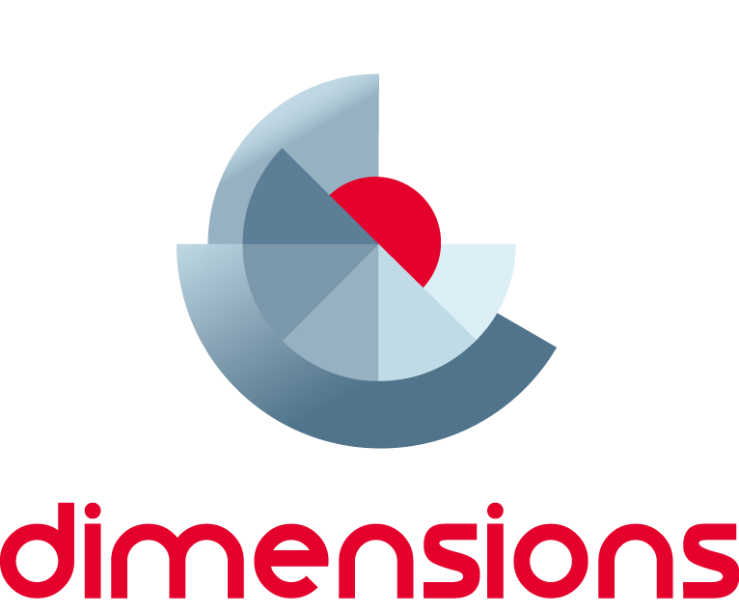

TDT Fractions:

Module 4 Assessment
  - Information for teachers
Top Drawer Teachers (http://topdrawer.aamt.edu.au) is a web-based resource developed by the Australian Association of Mathematics Teachers in collaboration with Education Services Australia.
The Fractions drawer is one of six drawers which provide expert advice, teaching suggestions and classroom activities. This module is a guide to assessment in mathematics, focused on fraction conceptual knowledge and understanding.

About this module
This resource was developed by
Rachael Whitney-Smith
It is suitable for
Teachers of students in Years F to 10
The resources for this module include
Facilitator notes
Session slideshow (available as a PowerPoint and a PDF)
Think Board Template (one per group)
Download 1: Choosing the Fraction model
Download 2: Choosing the response type
Download 3: With or without context
This module is
The fourth in a series of six modules on fractions
Designed to take between 25 and 45 minutes
Learning outcomes
- To identify the purpose of assessment
- To provide teachers with some assessment strategies that demonstrate students’ deeper understanding of fractions
- To identify fractional content assessed in national and international numeracy testing
AITSL Standards addressed
Standard 1: Know students and how they learn
- 1.2 Understand how students learn
Standard 2: Know the content and how to teach it
- 2.3 Curriculum, assessment and reporting
Standard 3: Plan for and implement effective teaching and learning
- 3.4 Select and use resources
Standard 5. Assess, provide feedback and report on student learning
- 5.1 Assess student learning
Standard 6: Engage in professional learning
- 6.2 Engage in professional learning and improve practice

Background
Fractions and Decimals are a sub-strand of the ‘Number and Algebra’ strand of the Australian Curriculum: Mathematics F - 6. From Year 7 and beyond, fractions form a part of the Real Numbers sub-strand of ‘Number and Algebra’.
Year 7 is the final year that fractions are explicitly taught within the Australian Curriculum: Mathematics and for the duration of mathematics they form part of the assumed knowledge students are expected to have learned. Fraction knowledge is also assumed within the Statistics and Probability strand from Year 5 and beyond.
National and international assessments such as NAPLAN, TIMSS and the majority of Numeracy assessments contain a high percentage of fraction related questions. If students have developed misconceptions surrounding their fractional understanding this will heavily impact upon their mathematical performance and numeracy development.
These facilitator notes are written to support the delivery of the module. It is recommended that you read them and any supporting materials thoroughly.
You may decide to exclude some activities depending upon the time available and the interests and backgrounds of the participants.

Resources
Choosing the Fraction model (1 per participant)
Choosing the response type ( 1 per participant)
With or without context (1 per participant)
Think Board Template (1 per group)
Markers
A3 or Butchers Paper for brainstorming
Internet access to access web links during the presentation (if not available you will need to take screen shots of the web pages)

Slides 1 – 3: Module Introduction
The first 3 slides outline what the module is about and what proficiencies the module is aimed at addressing mapping to the AITSL Professional Standards for Teachers.

Slide 4: Teacher Activity
In groups, participants complete the “Think Board Template” on Assessment. See below for an example.

Slide 5: Assessment
In education there are three main types of assessment each with a specific purpose. Diagnostic assessment is generally conducted at the beginning of a lesson block. It is aimed at determining what prior knowledge students have and what they have retained. Formative assessment is an ongoing tool valuable for both the learner, in providing ongoing feedback as to where they are at, and the teacher to assist in lesson planning and direction. Summative assessment provides feedback on what students have been able to learn. It generally takes place after a lesson block and it informs all interested parties what learning took place.

Slide 6: What Should Assessment Do?
You may choose to align these points to the participants “Think Boards” and share thoughts. The main point on this slide is that Assessment should be about the learning and not about the teaching. It can inform reporting but it isn’t just about reporting and grading of students.

Slide 7: Assessment in the TDT
This slide contains a hyperlink to the TDT Fractions Drawer - Assessment section. You may choose to demonstrate the menu options to the participants and get them to access the page via their own device or present it to the whole group via the PPT presentation. Explaining to the group that the Assessment menu option is divided into 2 sections, Assessment Approaches and Designing Assessment tasks which will be further explored throughout the workshop.

Slide 8: Assessment Approaches
There are many different approaches to assessment in mathematics. Traditional pen and paper tests are becoming less informative of learning and can cause “maths anxiety” in students as well as placing a focus on correct answers rather than process and conceptual understanding. Assessment approaches need to be consistent with the teaching approaches adopted during the lesson block. If students are using manipulatives to model mathematics or digital technologies to solve classroom problems, then these should be made available to students during assessment. If the assessment task requires students to demonstrate their ability to reason or problem solve, then they should have had the opportunity to do this during the learning activities.

Slide 9: Qualitative Assessment Approaches
This slide contains hyperlinks to the examples in the TDT Fractions Drawer. There are also associated notes on each approach which can be found through the following hyperlinks or by allowing teachers to navigate through the Assessment menu in the Fractions drawer.
Observation
Student Surveys
Task-based interviews
Digital Assessment tools
Slide 10: Planning for Fractions Assessment
There are some key questions you need to ask yourself prior to planning assessment as they will assist you in the approach you take and the tools you use.

Slide 11: What am I assessing for?
Is my assessment to be used as a diagnostic tool, a formative tool or a summative tool?
The purpose of an assessment will guide the construction and planning. For diagnostic assessment you may need to refer to prior knowledge and the previous year’s curriculum content. When conducting formative assessment you are informing the learner where they are at, but also informing yourself on where they are at and then thinking of where they need to go and subsequently planning for this. Summative assessments are a reflection of learning. How did they go? Did they learn what was intended?

Slide 12: Diagnostic Assessment
This slide gives an explanation of diagnostic assessment. You could choose to give some examples of fraction diagnostic assessments such as Tierney Kennedy’s Misconceptions Test or the Department of Education WA “First Steps: Number Diagnostic Tasks”

Slide 13: Teaching Activity
In groups participants can share ideas about how they could diagnostically assess students and any tools they have used in the past. You may choose to share with the whole group or keep it within the small groups and collect the information to share later.

Slide 14: Diagnostic Assessment Strategies
You may choose to give some examples of these and link to sites such as:
Department of Education Victoria
KAHOOT
Notepad
PADLET

Brainstorming

You may also like to incorporate these applications into your workshop by using KAHOOT for spot quizzes on the content ie: What are the 3 types of assessment? etc. or using padlet to house documents and the presentation PPT. This way participants will get to experience the applications in a real context.

Slide 15: Diagnostic: Assessment for Planning
This slide gives a visual representation of how Diagnostic assessment can be used to inform your planning of a unit. Your diagnostic assessment task can assist you to answer the four questions and plan for the unit of work catering for the students you have and where they are at in their learning.

Slide 16: Formative Assessment
This slide provides information about what Formative Assessment is and what it should be used for.

Slide 17: Formative Assessment Strategies
You may choose to provide examples of the strategies on this slide especially if participants have not used formative assessment strategies before. You can determine this through a brief survey of participants prior to running the workshop using survey monkey or another online survey tool or during the session to determine how much time needs to be spent giving examples of formative assessment strategies.

Slide 18: Formative Assessment for Learning
This slide gives a visual of how Formative assessment can guide the learning process. It outlines the educational benefits of using this in the classroom.

Slide 19: Summative Assessment
This slide provides information about what Summative Assessment is and what it is used for.

Slide 20: Summative Assessment
This slide provides a list of examples of Summative Assessment.

Slide 21: Summative Assessment of Learning
This slide gives a visual of how Summative Assessment is used in the learning process.

Slide 22: Designing Fraction Assessment Tasks
The choice of fraction model is important as students are expected to model fractions in a variety of ways in order to demonstrate their understanding. To ensure that students have developed a thorough understanding of fractions in different contexts assessments need to explore this in their questioning. The use of either closed or open tasks is dependent upon the purpose of the assessment. An open task will allow students to demonstrate more of their understanding, whereas closed tasks are good for determining whether desired outcomes have been met. Careful consideration should be made when choosing the response type.

Slide 23: Examples
This slide has hyperlinks to the sections in the TDT Fractions Assessment menu. You can refer to the 3 handouts (Downloads 1,2 & 3) and click on the hyperlinks one at a time to provide information on designing assessment types.

Slide 24: Teacher Activity
You may choose to omit this slide if your time for the workshop doesn’t permit completing this activity or you have participants from varying teaching year levels.

Slide 25: National Assessment Program
This slide has a hyperlink that takes you to ACARA’s web site outlining briefly the National Assessment Plan.

Slides 26 - 29: Assessment of Fractions in NAPLAN
The following 3 slides are presented to give an idea of the kind of fraction questions that can arise in NAPLAN testing. You may choose to add additional questions or explore this further at web sites such as 3P Learning or from NAP National Assessment Program

Slide 30: Further Information
A list of links to find more information on assessment of fractions.

Slide 31: Self reflection Activity
- Were the learning outcomes of this session achieved?
- How do you know?
- Do you need any more information?
- What will you take from this session to try and implement in your classroom?

Slide 32: Acknowledgments
The content of the drawer is supported by the extensive research into the learning of fractions carried out by several groups of researchers across Australia, some of which was published in a book edited by Dr Jennifer Way and A/Prof. Janette Bobis from The University of Sydney, titled Fractions: Teaching for Understanding (2011, AAMT).

Further ideas
Hinge point questions
Mathematics Assessment in Primary Schools: Make it count By R Callingham
The Practice of assessing mathematics learning (2008) AAMT position paper
https://www.qcaa.qld.edu.au/downloads/publications/report_students_understanding_fractions.pdf
http://www.naplanresources.com.au/year3-numeracy/

