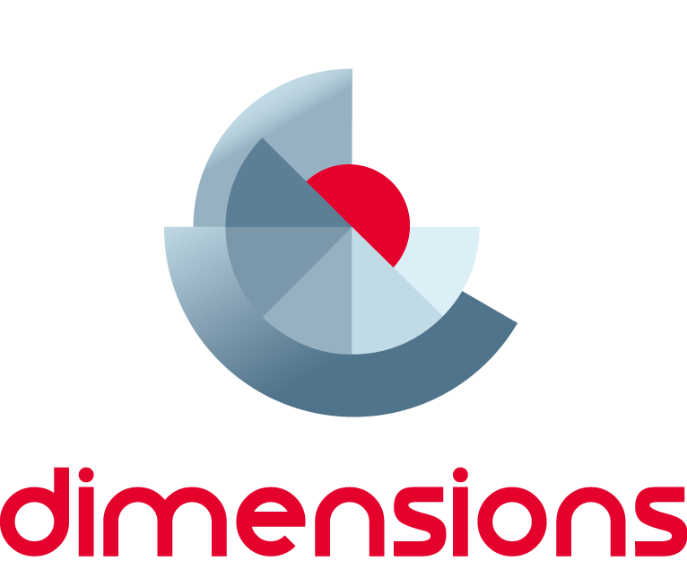

TDT Geometric Reasoning:

Module 2 – Congruency and Similarity
  - Information for facilitators
Top Drawer Teachers (http://topdrawer.aamt.edu.au) is a web-based resource developed by the Australian Association of Mathematics Teachers in collaboration with Education Services Australia.
The Geometric Reasoning drawer is one of six drawers which provide expert advice, teaching suggestions and classroom activities. This module is a guide to two of the ‘big ideas’ of Geometric Reasoning.

About this module
This resource was developed by
Ann Ruckert
It is suitable for
Teachers of students in Years 8 to 9
The resources for this module include
Facilitator notes
Session slideshow (available as a PowerPoint and a PDF)
Download 1: Paper, pencil and protractor: Student worksheet
Download 2: Paper, pencil and protractor: Solutions
Download 3: congruent triangles
Download 4: Similar triangles
Video ‘Non-similar and Similar Triangles’ from https://vimeo.com/74426347
This module is
The second in a series of four modules on Geometric reasoning
Designed to take between one to 1½ hours; it can be presented in two sections.
Learning outcomes (outlined in Slide 3)
Participants will
- Understand why congruency and similarity are powerful ideas in geometry.
- Be able to identify figures as being congruent or similar, explain the difference between congruent and similar figures and construct congruent and similar figures.
Please emphasise that:
Knowing that two figures are congruent is important as it becomes the means by which we can prove many geometric results.
Similarity relates enlargement, scale factor, area growth, indirect measurement, and projective geometry.

AITSL Standards addressed
Standard 1: Know students and how they learn
1.2 Understand how students learn
Standard 2: Know the content and how to teach it
2.1 Content and teaching strategies of the teaching area
2.2 Content selection and organisation
Standard 3: Plan for and implement effective teaching and learning
3.4 Select and use resources
Standard 6: Engage in professional learning
6.1 Identify and plan professional learning needs
6.2 Engage in professional learning and improve practice

Background
Geometric Reasoning is a sub-strand of the Measurement and Geometry strand of the Australian Curriculum: Mathematics.
These notes are written to support the delivery of the module. It is recommended that you read them and any supporting materials thoroughly.
You may decide to exclude some activities depending upon the interests and backgrounds of the participants.
Clicking on http://topdrawer.aamt.edu.au/Geometric-reasoning/Big-ideas will take you to the Big Ideas in Geometric Reasoning page of Top Drawer Teachers. It is possible to navigate throughout the drawer from here and it is suggested that the PowerPoint is used as an introduction to the Congruence and Similarity resources, with teachers then able to discover what else is available after the presentation.
Please share the following aside with participants in the presentation.
An aside about the teachers’ notes in Top Drawer Teachers:
- It is very tempting, as time-poor teachers, to jump straight into the activities and resources that can be used with your students… BUT DON’T – you and your students won’t gain full value from this resource if you do.
- The resources available here have been trialled in classrooms.
- Many teachers find geometric reasoning difficult to teach and the teachers’ notes & documentation around the work clarify the rigour of this very well.

Resources
Hand-outs: Paper, pencil and protractor: Student worksheet and Paper, pencil and protractor: Solutions
Hand-out: congruent triangles
Hand-out: Similar triangles
Hand-out: the Similar-Congruent House, available from https://www.superteacherworksheets.com/geometry/congruent-house_TZNMW.pdf
The facilitator will need to obtain/download photographs/pictures of:
- Tiling/patchwork patterns (could download photographs of the tiles found in the Alhambra, Granada)
- the Sydney Harbour Bridge
- Parkes Radio Telescope
- high-voltage transmission lines
- other photographic examples of congruent triangles in construction
Pattern blocks
A4 paper (some for each participant), pen/pencil
Scissors, rulers (straight-edges), protractors/geoliners, compasses
Computer and internet access
Internet access – each participant will need to access the learning object L11103: Using a centre of enlargement. They will be required to log into Scootle in order to do so (http://www.scootle.edu.au/ec/viewing/L11103/index.html ).
Internet access to http://nrich.maths.org/1938, Pentakite, a task on the NRICH website
Dynamic geometry software (Geogebra, etc) might be useful

Slide 2: Big ideas
There are five Big Ideas in the Geometric Reasoning Top Drawer. We are going to look at Geometric Reasoning in Year 8 with Congruence and in Year 9 with Similarity. The remaining two Big Ideas build on the knowledge and understanding of plane shapes, congruence and similarity.

Slide 4: Australian Curriculum Links
Many of the pages on which congruence and similarity are discussed contain links to the Australian Curriculum present to the right of the page in a grey box. These contain links to the Australian Curriculum content description and elaboration for each item, links to Scootle (resources & community) and to ScOT (Schools Online Thesaurus); which will assist in relating this session to topics being taught in the classroom.

Slide 5: Focus Question
Students can experience difficulty in knowing which test to use when determining triangles to be either similar or congruent. They can demonstrate misunderstandings and difficulties correctly identifying and naming corresponding sides and angles. For example, not understanding the importance of correctly identifying the matching sides in a triangle when establishing similarity may result in a student reaching incorrect conclusions about proportions.

During the presentation ask participants to consider the focus question:
“Will exploring the minimum conditions required for triangles to be congruent or similar, help students to develop a better understanding of the nuances/subtleties of the tests for congruency and similarity?”
Ensure that all participants understand what the focus question is asking. Ask participants to discuss what they do currently to help students to determine congruency and similarity in plane shapes, particularly triangles. Do they feel their students benefit from what is being done currently in the classroom?


Slide 6: Congruency: what is it?
Lead a discussion with the participants in which they consider:
- What they understand by the term, ‘congruency’.
- Share how it has been defined by the members of the group.
- Any examples of congruency in the ‘real world’ that they can share?
- What they do currently to help students to determine congruency in plane shapes, particularly triangles.
- Whether they feel their students benefit from what is being done currently in the classroom?

Slides 7 to 9: Congruency: what is it?
Plane shapes are congruent when they have the same shape and are the same size.
Congruent shapes can be superimposed on each other by rotation, translation or reflection, or a combination of these transformations.
For shapes to be congruent they must satisfy both the following conditions:
- matching (or corresponding) angles are equal
- matching (or corresponding) sides are equal in length.
These two shapes have matching angles equal but their matching sides are not equal and so they are not congruent. They are the same shape but not the same size.
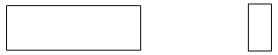
Non-congruent rectangles.
These two polygons have matching sides equal but their matching angles are not equal and so they are not congruent. They are different shapes even though the sides are the same size.
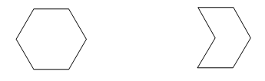
Non-congruent hexagons.
Congruent shapes can be superimposed on each other by rotation, translation or reflection (or a combination of these transformations).
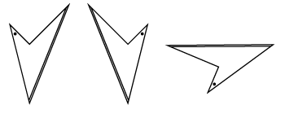
All of these quadrilaterals are congruent.
Congruence can be a feature of any type of plane shape.
The next four slides will allow participants to explore the link between congruent shapes and transformations further.
There are special conditions for congruent triangles.

Slide 10: Congruency in design

Congruent shapes are used extensively in design.
Explore real life patterns such as those in tiling and patchwork.
- Cut out shapes from within a design (you could download photographs of the tiles found in the Alhambra, Granada) and place them on top of each other.
- Discuss the sequence of transformations required to map one shape onto another: translation, rotation and reflection.
- Use pattern blocks to construct designs based on congruence.
  - Provide participants with a cut-out of a specific shape which they can use to re-draw the shape in a new orientation.
For example, draw ABCD in the new orientation indicated by A’B’.
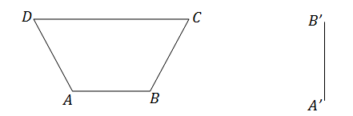
Subsequently, provide participants with activities which require them to draw transformations of shapes without the aid of a real object.
Students find challenge in constructing designs which involve rotations.
- Provide objects which can be manipulated physically to assist.
- Use polar grid paper to complete the rotation and then trace the resulting shape onto square grid paper.
- Highlight the matching sides and angles in different colours to ensure that they are equal.
You may prefer participants to work through this individually or in pairs. Give them sufficient time to work through the activity and then lead a discussion around:
- How they might implement the activities in their classroom.
- What student outcomes might they expect to observe?
- Do they feel that this is a worthwhile activity to use with their students?
- How might they adapt it to suit their students? etc…

Slides 11 & 12: Congruency in design: Alhambra tiles
This activity, taken from Swan and Crust (1993) Mathematics Programmes of Study, Inset for Key Stages 3 and 4, National Curriculum Council, York, can be used as an inquiry-based learning activity to allow participants and students to visualise congruency in a tiling pattern. As demonstrated in slide 12, there are two different congruent patterns present.

In order to allow participants to convince themselves that this is so, enlarge the pattern
of the tiles, print and then laminate this before cutting the pattern into the composite tiles. Being able to manipulate the individual tiles will allow participants to realise that rotation does not result in the second pattern being formed. They might also be able to determine that reflection does result in the second pattern being formed (but how often do we reflect tiles?)
Lead a discussion around this activity, especially about how participants might use
a similar activity in the classroom and what they might do to adapt this to suit their students.

Slide 13: Congruency in construction
Download (from the internet) and examine photographs of:
- the Sydney Harbour Bridge,
- Parkes Radio Telescope,
- high-voltage transmission lines
- other photographic examples of congruent triangles (and other shapes) in construction
and lead a discussion around the appearance and location of congruent shapes (mainly triangles) and their purpose.
Discuss whether this could be a useful activity in the classroom to link the concept of the importance of congruency with real life examples.

Slide 14: Activity: Paper, pencil and protractor
With congruent triangles, many students do not understand the importance of the qualifiers of 'included angle' in the SAS test nor the 'corresponding side' in the AAS test.
To convince students of the validity of the congruence tests for triangles, it is useful to investigate all the triangles which satisfy three given conditions. By constructing the triangles, both in a pen and paper environment and in a virtual environment, students realise that there can be more than one triangle constructed.

In this activity, participants will construct all possible triangles which have three given measurements. They will determine the conditions under which congruence can be guaranteed. This activity is most effective when participants work in groups of three or four. Ensure each participant (or group) has a copy of Paper, pencil and protractor: Student worksheet. Each participant will produce their own constructions and the group then will compare their results. Some ideas to help comparison and discussion within the group:
- Three given sides
Some groups will need to cut out the triangles and place them on top of each other to see that they really are transformations of the same triangle. The combination of reflection and rotation is difficult for students to visualise without concrete materials.
- Two given sides and an angle
Often the angle will be placed in the included position and participants will be unable to draw other configurations. Careful questioning and discussion will help them find the other two possible versions.
- Two given angles and one side
If participants cannot find alternatives, hint that the angle sum of a triangle will help.
- Right-angled triangles with two given side lengths
It is valuable to discuss why there are only two options, one of which is actually the SAS situation.
The solution can be found at Paper, pencil and protractor: Solutions which provides accurate diagrams of all the triangles that can be constructed under the given conditions.
Ensure that you are familiar with this activity and have attempted it before the presentation as you may have to clarify some concepts and skills while participants are engaged with the activity.
Lead a discussion around how to implement this activity in the classroom and how it might support student learning.


Virtual Congruence
There is no PowerPoint slide for this activity as it appears that Java (required to run this virtual activity) does not work under all systems. If you can access the activity, it is engaging and stimulating and worth doing with students.
In this activity, participants manipulate virtual diagrams and confirm the congruence tests. Once the triangles are constructed, they can be transformed and superimposed on each other.
You will need access to the internet for this activity which works best when each participant has individual access to the learning objects.
The aim of this virtual congruence activity (National Library of Virtual Manipulatives, Utah State University at http://nlvm.usu.edu/en/nav/frames_asid_165_g_3_t_3.html?open=instructions&from=category_g_3_t_3.html) is for participants to form two triangles that are congruent. They choose which congruence test they want to explore and are then presented with two sets of measurements, one red and the other blue. Each set of measurements matches one of the congruence tests.
Once the triangles have been completed, participants can rotate, translate or reflect the images to place one on top of the other. This confirms the congruence of the triangles. Participants could then discuss their findings in small groups.
The interactive also has extensive explanations of the congruence test under consideration.

Slides 15 & 16: Congruency Quick Quiz
Ensure each participant has a copy of congruent triangles which summarises the concepts and congruency rules covered this far.
These two slides will ensure that all participants understand the meaning of the terms; matching sides and included angles. Ask participants to record their answers before giving them the correct answers, which are:
Slide 15 – AB and XY are matching sides as they are both opposite θ. PQ is not a matching side.
Slide 16 – θ is the included angle, α is not the included angle
Lead a discussion around the ways that teachers support student learning and understanding of these concepts. What strategies could be used? Record these on Post-it notes or butcher’s paper (etc).

At this point you may wish to stop the presentation and continue it at another time, or you may wish to continue.

Slide 18: Similarity: what is it?
Lead a discussion with the participants in which they consider:
- What they understand by the term, ‘similarity’.
- Share how it has been defined by the members of the group.
- Any examples of similarity in the ‘real world’ that they can share?
- What they do currently to help students to determine similarity in plane shapes, particularly triangles.
- Whether they feel their students benefit from what is being done currently in the classroom?

Slide 19: Similarity
Similar figures have the same shape, but not necessarily the same size. Two plane figures are called similar if one can be enlarged so that it is congruent to the other figure.
For shapes to be similar they must satisfy both the following conditions:
- matching angles are equal
- matching sides are proportional.
These two rectangles have matching angles equal but their matching sides are not in the same ratio and so they are not similar.
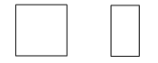
Non-similar rectangles.
These two hexagons have matching sides in the same proportion and their matching angles are equal and so they are similar.
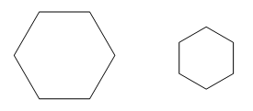
Similar regular hexagons.


Slide 20: Using a centre of enlargement
For this activity, participants will need to be able to access the internet and will need to log into Scootle.
Investigate further the effect of the changing proportion of sides for similar shapes with the learning object L11103: Using a centre of enlargement (http://www.scootle.edu.au/ec/viewing/L11103/index.html).
The learning object includes an activity sheet with four tasks on it that require access
to the Widget: Using a centre of enlargement. In the widget, participants will be able
to manipulate the image to change the degree of enlargement of one triangle compared
to another. They can compare scale factors and observe what happens when the centre
of enlargement is moved.
This activity will allow participants (and students) to understand how the centre
of enlargement works, without having to draw (often incorrectly) the diagrams.
Lead a discussion about how this can be used in a Year 9 classroom to consolidate student understanding of a fairly difficult concept.


Slide 21: Video: Non-similar and similar triangles
The picture of the video is hyperlinked to the Vimeo video at https://vimeo.com/74426347 . The video is 1½ minutes long and demonstrates that the ratio of the lengths of the three corresponding sides in similar triangles remain equal, no matter how much larger one triangle is than the other. This is one of the four tests for similarity – “If each of the sides of one triangle can be matched up with each of the sides of another so that the ratios of matching sides are equal, then the two triangles are similar”.

Slide 22: Similarity
Ensure that each participant receives a copy of Similar triangles.
Pairs of triangles are similar if they meet the conditions of any one of four standard tests.
These tests are:
- Angle Angle Angle (AAA)
If two angles of one triangle are respectively equal to two angles of another triangle, then the two triangles are similar.
It is sufficient to prove that only two pairs of angles are respectively equal to each other. Because the angle sum of a triangle is always 180°, the third pair of angles will automatically be equal. Re-stating this fact is not required when using the AAA test in a similarity proof.
- Side Angle Side (SAS)
If the ratio of the lengths of two sides of one triangle is equal to the ratio of the lengths of two sides of another triangle, and the included angles are equal, then the two triangles are similar.
- Side Side Side (SSS)
If each of the sides of one triangle can be matched up with each of the sides of another so that the ratios of matching sides are equal, then the two triangles are similar.
- Right-angle Hypotenuse Side (RHS)
If the ratio of the hypotenuse and one side of a right-angled triangle is equal to the ratio of the hypotenuse and one side of another right-angled triangle, then the two triangles are similar.
Make sure all participants are familiar with these tests and how they differ from the tests for congruency.

Slide 23: The similar-congruent house
Ensure all participants have a copy of the Similar-Congruent House, available from https://www.superteacherworksheets.com/geometry/congruent-house_TZNMW.pdf. Don’t give them page 2 (the answer sheet) until they have answered the 9 questions on the page. Keeping time constraints in mind, you might ask participants to look through the sheet so that they can see how it works, without having to complete it. This worksheet allows participants (and students) to decide whether each pair of shapes is congruent or similar, without having to prove their answers. In the classroom, teachers might like to ask students to colour congruent shapes the same colour.
Lead a discussion around how and when this activity might be useful to use in lessons. Are there any changes/adaptations that participants might make to it?

Slides 24 – 33: Looking beyond the lines
Geometrical diagrams can be complex to decipher. Students may experience difficulty separating out shapes when they overlap or recognising angle relationships.
This series of slides contains the presentation, Looking beyond the lines slide show presentation, in which the required triangles are coloured and then translated out of the diagram. After separating them from within the more complex diagram, and marking equal angles, the similar triangles are more obvious.
In order to make the similar triangles even more obvious for some students, it might be useful to have a similar activity where students are able to cut out the triangles and move them around (even overlaying them) so that it is obvious that they are the same shape.
Ask the participants how useful they think this activity might be and whether they have considered carrying out activities similar to this with their students.

Slide 34: Activity: Pentakite
This activity is included as it calls for simple geometrical reasoning involving angles and similar triangles. It is a good way in to the wonderful mathematics related to the golden ratio and the Fibonacci sequence. However, only ask participants to work through the activity if time permits.
Ensure that each participant is able to access http://nrich.maths.org/1938 and allow them to work through the activity (either individually or in pairs).
Pentakite is a task on the NRICH website which entails geometrical reasoning involving angles and similar triangles.
A diagram is not provided in the task, thereby participants are encouraged to draw their own.
As well as geometrical similarity, the task opens up links to the golden ratio and the Fibonacci sequence.
There is a suggested answer on the NRICH website, but be aware that it goes into much greater depth than is required by the activity.
At the conclusion of the activity, lead a discussion into the validity of this activity for students; can the participants see how they could use an activity such as this with their students, when and where?

Slide 35: Conclusion
Now that everyone has completed this module, consider the focus question posed at the beginning of the presentation. Ask everyone to share their thoughts, ideas, wonderings with each other and record responses for dissemination amongst the group. This might act as a stimulus to help them alter the way in which the ideas of congruency and similarity are taught.

Summary
- Did we achieve the learning outcome?
- How do we know?
- Do we need any more information?
- Where will we go to get it?
- What will I try in my classroom?

