

TDT Geometric Reasoning:

Module 4 – Circle Geometry
  - Information for facilitators
Top Drawer Teachers (http://topdrawer.aamt.edu.au) is a web-based resource developed by the Australian Association of Mathematics Teachers in collaboration with Education Services Australia.
The Geometric Reasoning drawer is one of six drawers which provide expert advice, teaching suggestions and classroom activities. This module is a guide to one of the ‘big ideas’ of Geometric Reasoning.

About this module
This resource was developed by
Ann Ruckert
It is suitable for:
Teachers of students in Year 10 (10A)
The resources for this module include:
Facilitator notes
Session slideshow (available as a PowerPoint and a PDF)
Download 1: circle geometry theorems
Download 2: Circle geometry investigations: Student worksheet
This module is”
The fourth in a series of four modules on Geometric reasoning
Designed to take approximately one hour.
The following is covered in Slide 3
Learning outcomes
Participants will:
- learn how to argue and reason deductively in geometric situations using circle theorems.
- confidently scaffold the process of writing geometric proofs of circle theorems for their year 10 students.
AITSL Standards addressed
Standard 1: Know students and how they learn
1.2 Understand how students learn
Standard 2: Know the content and how to teach it
2.1 Content and teaching strategies of the teaching area
2.2 Content selection and organisation
Standard 3: Plan for and implement effective teaching and learning
3.4 Select and use resources
Standard 6: Engage in professional learning
6.1 Identify and plan professional learning needs
6.2 Engage in professional learning and improve practice

Background
Geometric Reasoning is a sub-strand of the Measurement and Geometry strand of the Australian Curriculum: Mathematics.
These notes are written to support the delivery of the module. It is recommended that you read them and any supporting materials thoroughly.
You may decide to exclude some activities depending upon the interests and backgrounds of the participants.
Clicking on http://topdrawer.aamt.edu.au/Geometric-reasoning/Big-ideas will take you to the Big Ideas in Geometric Reasoning page of Top Drawer Teachers. It is possible to navigate throughout the drawer from here and it is suggested that the PowerPoint is used as an introduction to the Circle Geometry resources, with teachers then able to discover what else is available after the presentation.
Please share the following aside with participants in the presentation.
An aside about the teachers’ notes in Top Drawer Teachers:
- It is very tempting, as time-poor teachers, to jump straight into the activities and resources that can be used with your students… BUT DON’T – you and your students won’t gain full value from this resource if you do.
- The resources available here have been trialled in classrooms.
- Many teachers find geometric reasoning difficult to teach and the teachers’ notes & documentation around the work clarify the rigour of this very well.

Resources
Hand-out: circle geometry theorems (If you have time, to laminate these as cards— as demonstrated in the photograph— and cut them out prior to the presentation. They can be reused later. You will also need a complete copy of the sheets to
give each participant at the conclusion of the activity.)
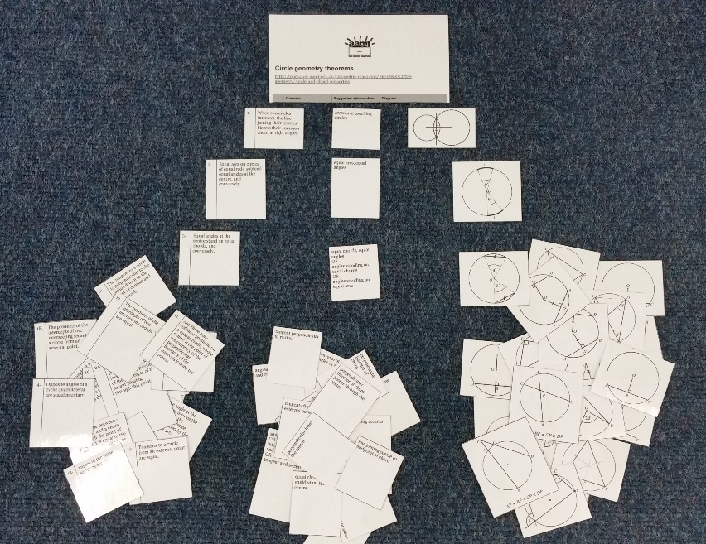
Hand-out: download from https://illuminations.nctm.org/Lesson.aspx?id=3777 the:
- Folding Circles Activity Sheet
- Circle Template
Hand-out: Circle geometry investigations: Student worksheet
A4 paper (some for each participant), pen/pencil, compasses, protractors, coloured pencils, rulers
Computer and internet access
Activity available from NCTM’s Illuminations at https://illuminations.nctm.org/Lesson.aspx?id=3777
Dynamic geometry software (Geogebra, etc) will be required and can be accessed via:
free GeoGebra software
Dynamic circle geometry files accessed via: dynamic circle geometry files on Geogebratube

Slide 2: Big ideas
There are five Big Ideas in the Geometric Reasoning Top Drawer. We are going to look
at Geometric Reasoning in Year 10A with Circle Geometry, which builds further on the knowledge and understanding of plane shapes, congruence and similarity, while consolidating the skill of constructing and understanding proofs.

Slide 4: Australian Curriculum Links
Circle geometry is a topic taught in the 10A course of the Australian Curriculum and the content description is: ‘Prove and apply angle and chord properties of circle’.
Many of the pages on which circle geometry is discussed contain links to the Australian Curriculum present to the right of the page in a grey box. These contain links to the Australian Curriculum content description and elaboration for each item, links to Scootle (resources & community) and to ScOT (Schools Online Thesaurus); which will assist
in relating this session to topics being taught in the classroom.

Slide 5: Focus Question
The theorems of circle geometry are not intuitively obvious to students. Most people
are quite surprised by the results when they first see them. They clearly need to be proven carefully.
During the presentation ask participants to consider the focus question:
“Could establishing classroom activities and discussions that allow students to explore circle geometry relationships in a number of different ways help them to prove the theorems using formal deductive geometry strategies?”
Ensure that all participants understand what the focus question is asking.
Ask participants to discuss what they do currently to help students to prove and apply angle and chord properties of circles, with understanding. Do they feel their students benefit from what is being done currently in the classroom?

Slide 6: Circle Geometry Activity: Angle & Chord Properties
Historically, the properties of the circle and its relationships were used extensively
in geometric construction and design.
The angle and chord properties in circle geometry provide opportunities to apply knowledge and skills, and uncover new relationships. The theorems of circle geometry
are not intuitively obvious to students and need to be proven carefully.
Knowledge and understanding of circle geometry relationships will help verify the techniques employed when constructing figures. Circle geometry also provides a context to apply the understanding of similar triangles with their associated proportions, as well as many other geometrical concepts.
It is particularly important to provide plenty of opportunities to explore the (many) angle and chord properties of circles.
The first step in deductive reasoning in circle geometry is recognising the angle and chord properties. Ordering the relationships sequentially then forms the foundation of a proof.
Many of the angle and chord properties of circles are inter-related and the order
of treatment becomes important.
For example, from the theorem 'the angle at the centre is twice the angle at the circumference standing on the same chord' comes the theorem 'angles in the same segment are equal'. From there, the product of the intercepts of intersecting chords
can be proven to be equal.
Presenting the theorems in an appropriate order allows students to apply knowledge
of the earlier theorems to prove subsequent results.

Ensure each pair of participants has a set of circle geometry theorems cards (previously laminated and cut up).
Ask them to match the cards so that each theorem (there are 21) is matched with its suggested abbreviation and diagram. Give them time to gain the idea of what the task involves, and to complete it if time allows.
Ensure each participant has a copy of the circle geometry theorems list so that they can check their card-matching and use in their classroom.

Lead a discussion that addresses:
- How the participants felt while completing the task
- How the activity might be used with their students to begin consolidating
the angle and chord properties of circles.

Slide 7: Deductive reasoning in circle geometry
Knowledge and understanding of circle geometry relationships will help verify the techniques employed when constructing figures. Circle geometry also provides a context to apply the understanding of similar triangles with their associated proportions, as well as many other geometrical concepts.
Provide your students with opportunities to make conjectures and then prove theorems. They can explore, predict and confirm through interacting with dynamic diagrams.
This will also strengthen their ability to visualise angle relationships and frequently prompts further conjecture.
Students will need:
- extensive practice in locating and evaluating angles
- guided experience in writing a proof (covered in Module 3: Geometric Proof).

Slide 8: Discussion review: To prove a theorem
Lead a discussion that allows participants to decide what steps are necessary when writing a geometric proof. This was covered in Module 3: Geometric Proof and it would
be useful for participants to have participated in Module 3 before this module.
A geometric proof is a logical sequence of connected statements with supporting reasons, leading to a specific conclusion.
- State the aim of the proof
- Use given information and previously established theorems to establish the result
- Give a reason for each step
- State a clear conclusion.
Remember that a proof is incorrect if there is:
- an error in the underlying assumptions
- a flaw in the logic of the reasoning.
Use these and the previous slide to check that all participants are familiar and confident with writing geometric proofs before progressing to the following slides.

Slide 9: Exploring Circles
A thorough understanding of circle geometry is best achieved when students explore
the relationships and see the results in a variety of situations, such as:
- Fold paper circles.
- Solve problems involving angle measurements.
- Construct accurately with pen-and-paper and then measure angles and lengths.
- Create dynamic diagrams which can be manipulated.
Once students have a clear understanding of the theorems it is both mathematically
sound and good teaching practice to prove the theorems using formal deductive
geometry strategies.
From there, more complex problems can be posed which require the students to link
the theorems.

Slides 10 & 11: Activity: Folding circles and discussion

Active learning in mathematics, where students are engaged in meaningful learning activities, is considered to be one of the most important principles for the learning
of maths. Folding paper is one way of adding active experience into maths lessons.
Forming straight lines by folding creases in a piece of paper is an interesting way of discovering and demonstrating relationships among lines and angles. Once a relationship has been shown by folding paper, formal work on it later does not seem so foreign. Paper folding not only simplifies the learning of mathematics; it also builds an experiential base necessary for further learning.
Ensure each participant (or group) has access to a computer and the internet. This activity requires them to work through one of NCTM’s Illuminations activities; “Folding Circles: Exploring Circle Theorems through Paper Folding” available at: https://illuminations.nctm.org/Lesson.aspx?id=3777 .
In this activity, participants will manipulate three paper circles to explore four circle theorems. Using paper folding allows the lesson to be more accessible to kinaesthetic learners.
Ensure each participant (or group) has copies of the:
- Folding Circles Activity Sheet
- Circle Template
As well as A4 paper, compasses, protractors, coloured pencils and rulers.
Lead a discussion around the Questions for Students and Teacher Reflection found via the tab towards the top of the web page. Is this an activity that participants feel would help their students with circle geometry?

Slide 12: Circle geometry investigations
In this series of activities, a particular situation in a circle will be investigated to form
a hypothesis. Further explorations using dynamic geometry software will then occur.

These activities begin with pencil and paper explorations.
Ensure that each participant receives a copy of the Circle geometry investigations: Student worksheet. Working in pairs, participants use the worksheet to form an hypothesis and write a simple explanation or annotate a diagram.
They then investigate further using the free GeoGebra software and write conclusions explaining what has been found. Interaction with dynamic diagrams lets participants explore multiple configurations of the same situation. It strengthens their visual skills while they are making and configuring their conjectures.
Precise wording of the details of the conclusions should be encouraged. This will assist when the formal wording of the theorems is encountered later.
The activities are graded in order of difficulty, participants should be encouraged to move on and investigate in GeoGebra, even if they cannot form a hypothesis. Similarly, if they experience difficulty with the dynamic constructions, they can move to the next activity and return later when assistance is available.
After the activities are completed, ask participants to explain their understanding. Discuss whether they feel that this series of investigations would assist student understanding
and consolidation of circle geometry theorems.
There is great benefit in investigating the theorems using dynamic diagrams.

Slides 13 & 14: Dynamic circle geometry
and discussion
In this activity, pre-prepared learning objects allow all participants to benefit from exploring dynamic circle geometry.
The dynamic circle geometry files on Geogebratube provide participants with the opportunity to interact, explore, predict and confirm results in circle geometry. They will be most valuable when the classroom learning encourages group work and discussion.
It is strongly recommended that the theorems are presented in the given numbered sequence (1– 15) and that no more than five theorems are covered in one session.
Subsequently, in the classroom, students will need to practise recognising the theorems in a wide variety of orientations. Providing plenty of exercises which require missing angles to be found will support this learning.
Verbal explanations of the reasoning are suitable to begin with. Later, more formally written proofs will become appropriate.
After participants have investigated some of the circle theorems, lead a discussion around the validity and usefulness of this activity in the classroom.
Interaction with dynamic diagrams lets students explore multiple configurations of the same situation. It strengthens their visual skills while they are making and confirming their conjectures. It is also helpful to:
- have students work in pairs
- require students to write about the results in their own words
- follow up the investigations with class discussion
- provide exercises which utilise the theorems.
Lead a discussion with participants around how these strategies might be used in
their classrooms. Are they currently using any of these to support student learning
and understanding of circle geometry? Are they utilizing any other strategies that
might be useful to share with the group?

Slide 15: Conclusion
Now that everyone has completed this module, consider the focus question posed at the beginning of the presentation. Ask everyone to share their thoughts, ideas, wonderings with each other and record responses for dissemination amongst the group. This might
act as a stimulus to help them alter the way in which the concepts of Circle Geometry
are taught.

Summary
- Did we achieve the learning outcome?
- How do we know?
- Do we need any more information?
- Where will we go to get it?
- What will I try in my classroom?

