

Opening the Top Drawer to mental computation

Module 1: What is mental computation and why is it important?
  - Information for facilitators
Top Drawer Teachers (http://topdrawer.aamt.edu.au) is a web-based resource developed by the Australian Association of Mathematics Teachers in collaboration with Education Services Australia.
The Mental Computation drawer is one of six drawers which provide expert advice, teaching suggestions and classroom activities. This module is a guide to the importance of, and reasoning behind, mental computation.

About this module
This resource was developed by
Ann Ruckert
It is suitable for
Teachers of students in Years 2 to 6
The resources for this module available on Dimensions include
Facilitator notes
Session slideshow (available as a PowerPoint and a PDF)
Download 1: Pre-reading: Morgan, G. (2000). Put Mental Computation First? Australian Primary Mathematics Classroom, 5 (3), 4-9
This module is
The first in a series of three modules on mental computation
Designed to take approximately 60 minutes
Learning outcomes (also addressed in Slide 3)
Participants should be able to:
- Describe what mental computation is.
- Determine why mental computation should be used in the mathematics classroom.
AITSL Standards addressed
Standard 1: Know students and how they learn
1.2 Understand how students learn
Standard 2: Know the content and how to teach it
2.1 Content and teaching strategies of the teaching area
2.5 Literacy and numeracy strategies
Standard 3: Plan for and implement effective teaching and learning
3.3 Use teaching strategies
Standard 6: Engage in professional learning
6.2 Engage in professional learning and improve practice

Australian Curriculum links
Pages within the Mental computation drawer contain links to the Australian Curriculum which appear to the right of the page in a grey box. These contain links to the content description and elaboration for each item, links to Scootle (resources & community) and to ScOT (Schools Online Thesaurus).

Background
Mental computation is addressed in the Number and Algebra strand of the Australian Curriculum: Mathematics, particularly Number and Place Value, and Patterns and Algebra.
These notes are written to support the delivery of the module. It is recommended that you read them and any supporting materials thoroughly.
You may decide to exclude some activities depending upon the interests and backgrounds of the participants.
Clicking on https://topdrawer.aamt.edu.au/Mental-computation will take you to the overview of the Mental computation drawer of Top Drawer Teachers. It is possible to navigate throughout the drawer from here and it is suggested that the PowerPoint is used as an introduction to these resources, with teachers then able to discover what else is available after the presentation.

Prior to presenting the PowerPoint, distribute the pre-reading, Morgan, G. (2000). Put Mental Computation First? Australian Primary Mathematics Classroom, 5 (3), 4-9; available as a download with this module. In this article, Geoffrey Morgan adds to the debate about the place of standard methods, the calculator and mental mathematics by proposing a framework for computation. A number of the points raised are discussed further in the slideshow presentation.
Ask participants to read the article before attending the professional learning presentation.

Resources
These need to be downloaded/made available for participants.
Pre-reading: Morgan, G. (2000). Put Mental Computation First? Australian Primary Mathematics Classroom, 5 (3), 4-9 (tdt_MC_morgan1.pdf)
A4 paper (some for each participant), pen/pencil
Access to the internet

Slide 2: The modules in this PL
The content in the Mental Computation Top Drawer will be addressed in three modules. In this module we will be examining what mental computation is and why it is important. The remaining two modules will be:
Module 2 of 3: Noticing patterns and relationships
Module 3 of 3: Using manipulatives to support mental computation

Slide 4: What is mental computation?
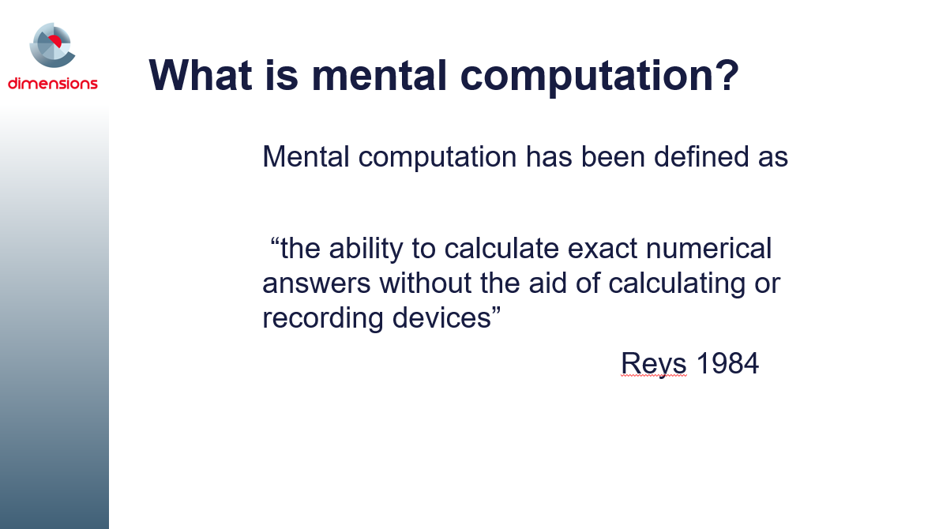
This introductory slide might be used as a prompt to ask participants what they consider mental computation to be.
Do they consider it to be an important component of their students’ learning?
Do they agree with Morgan’s statement, “…despite the ongoing advocacy for an increased emphasis on teaching rather than testing mental computation, this has yet to significantly translate into classroom practice”?.

Slides 5-7: Activity and discussion: Mental computation

Participants are asked to estimate the answer to the two-digit addition question, 38 + 59, record their estimation and then to mentally calculate the answer to the same question. Ensure that they record the strategy used to complete the mental calculation and then ask them to use a different strategy to mentally calculate the answer to the same question and record that strategy too. Emphasise that these calculations are to be completed mentally and not using pen & paper, mobile phone, calculator, computer….
Once participants have recorded their strategies, ask them to share these. It is useful to publicly record the different strategies on a whiteboard, sticky notes, or anywhere that all participants are able to see them.

Finally lead a discussion in which participants consider:
- Why they were asked to estimate the answer first.
- The different strategies used by participants in the room (there may not be many variations, but consider them all).
- The apparent efficiency of each strategy (this will be addressed again later in the module).

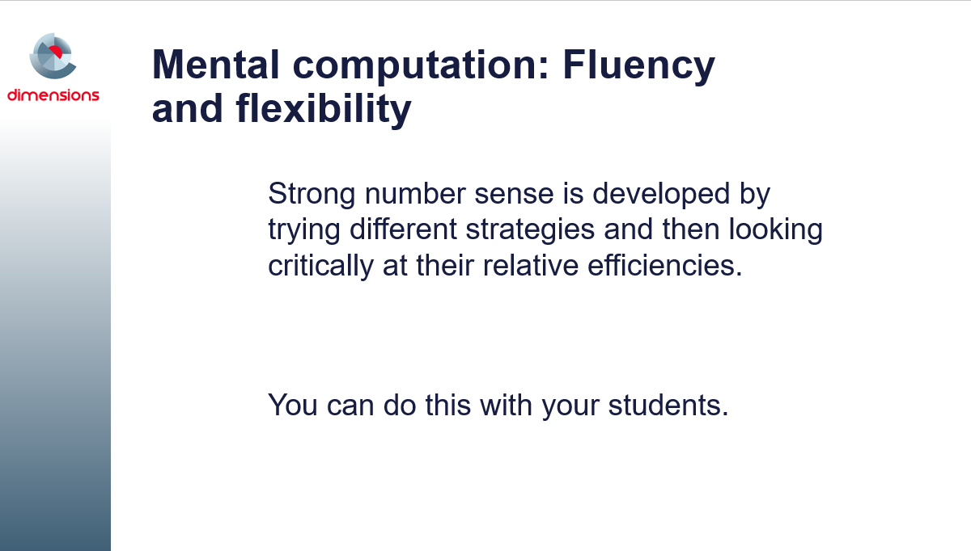
Slide 8: Mental computation: Fluency and flexibility
Fluency with mental computation is the ease with which a student carries out a calculation.
Flexibility is recognising the demands of a problem and choosing the best strategy for the numbers.
Ask participants to consider how they might have their students critically compare the efficiency of using different mental computation strategies. They could use the two digit question from the previous slide, or another problem if they prefer, e.g. 19 + 26, 63 – 28, 24 x 5, etc.

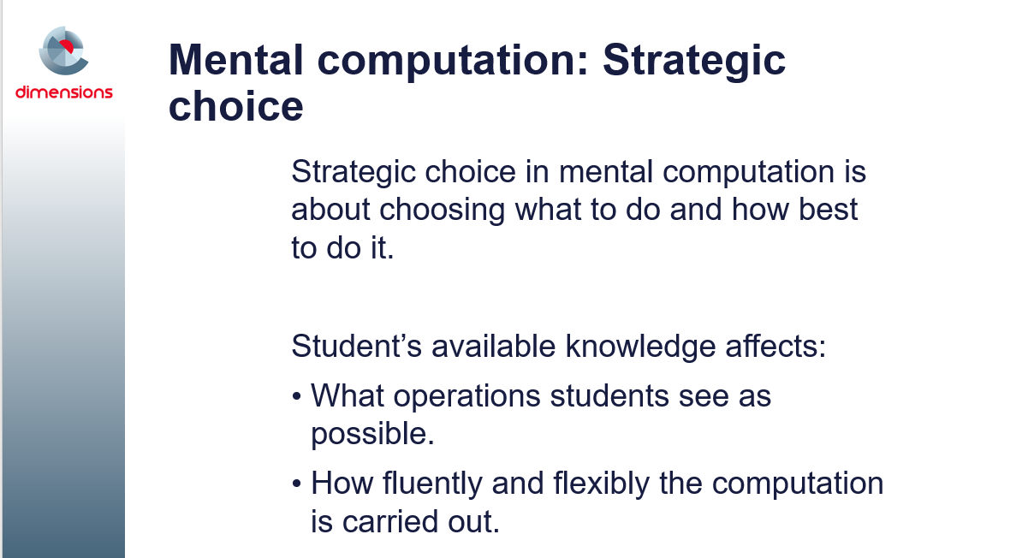
Slide 9: Mental computation: Strategic choice
Strategic thinking in mental computation is deciding which operation to use and then the best way to carry out that operation.
A student's available knowledge, in conjunction with their goals and beliefs, affects strategic choice in two ways.
- Knowledge influences what operations students see as possible.
For example, if a student has little knowledge of multiplication it is unlikely that they will use multiplication to solve a problem in which equal sets are combined. Instead they are likely to resort to counting or addition repeated methods. This might be thought of as 'know to' knowledge.
- Knowledge affects how fluently and flexibly the computation is carried out.
For example, students may know that repeated addition can be represented as multiplication. But if they do not know any relevant multiplication facts, they may still add or count to find an answer. This has implications for assessment in that the strategies students choose to use are influenced by access to number-dependent facts. A student might use counting, adding and multiplication strategies when solving equal sets problems.
At this point in the presentation it would be worth checking with participants that they are aware of the factors that complicate how well students carry out mental computation (particularly with reference to slides 8 and 9).

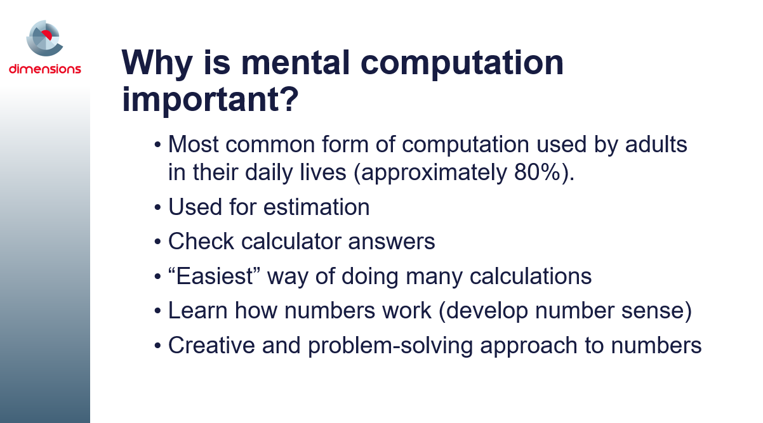
Slide 10: Why is mental computation important?
The information on the slide is adapted from McIntosh, A. (2005). Mental Computation: A Strategic Approach: Module 1 Introduction. 2nd Ed. Department of Education, Tasmania
Research also indicates that an emphasis on mental computation can improve students' development of number, while an early introduction to formal written methods (written algorithms) can harm it.
“An algorithmic approach to mathematical computations promotes passive responses from students (Thompson, 1999). Mental computation in contrast requires more active participation. Students, when using mental computation, are more likely to thoughtfully engage with the problem and apply conceptual knowledge to assist in the selection of appropriate strategies. According to Callingham (2005) further research is needed into the relationship between algorithms and conceptual understanding in the area of mental computation.”
Clark, J., (2008). Year Five Students Solving Mental and Written Problems: What Are They Thinking? In M. Goos, R. Brown, & K. Makar (Eds), Navigating currents and charting directions. (Proceedings of the 31st Annual Conference of the Mathematical Education Research Group of Australasia, pp. 131-137). Brisbane: MERGA
The following disturbing example of these point made in the previous paragraphs is taken from Clarke, D. M., (2005). Written algorithms in the primary years: Undoing the ‘good work’? In M. Coupland, J. Anderson & T. Spencer (Eds), Making Mathematics Vital (Proceedings of the 20th Biennial Conference of the Australian Association of Mathematics Teachers, pp. 93-98). Sydney: The Australian Association of Mathematics Teachers.
“The researchers discussed the case of Jamie (a second grade girl), who was interviewed on several occasions during the school year. It is important to note that Jamie had not met conventional algorithms prior to second grade, but was introduced to them during second grade.
Early in the school year, Jamie successfully added 19 and 26 mentally: ‘I know I have 30 because I have a group of ten and two more tens. Then if I take 1 from the 6 and give it to the 9, I’ll have another group of 10. That leaves five left, so the answer is 45.’
After five months of school and work with conventional algorithms, Jamie attempted to add 34 and 99 by beginning to group the 9 tens and 3 tens, then stopped and said, ‘Oh, I have to add the ones first.’ She then grouped the units, and traded for a ten to solve the problem.
In the last month of the school year, asked about the possibility of solving the problem by adding the tens first, Jamie emphatically stated, ‘No, you never add the tens first.’ She was invited to suggest another way that the problem could be solved. Jamie suggested that another way to solve the problem might be to know the answer from memory. Finally, she was confronted with her own invented strategy, from earlier in the year, as a strategy ‘someone used’ to add 49 + 19 (‘I think of 50 + 19 and then subtract one to get 68’). When asked if she thought this method might work, she replied ‘If you know that way, it’s okay, but it’s much, much better to just add the ones first.’ (p. 259)
This one example is a powerful demonstration of the way in which a child can move from trusting their understanding of numbers and flexible strategies to following a single procedure without much hesitation.”
Mental computation acts as a means for promoting thinking, conjecturing, and generalising based on conceptual understanding. There is its social utility to consider as well as the development of number sense, through the fostering of a deep understanding of the structure of numbers and their properties.
If you have time, share the stories/information above with participants. They are a powerful way of emphasizing the importance of mental computation in the primary years.
Each of the points from slide 10, Why is mental computation important?, are elaborated in the slides that follow.

Slides 11 – 12: Adults and mental computation
In these two slides, participants are first asked to consider where they would perform mental calculations in real life, and what types of calculation methods they might use during these situations. Something that instantly springs to my mind, having just experienced it, is mentally calculating whether I have enough petrol in the car to make it to the next petrol station when the warning light is flashing and the nearest petrol station is more than 50km away.
Lead a discussion around the two questions on the slides before moving on to Slide 12 where some examples are listed. It might be worth recording the examples brought out by participants publicly as that will help to trigger the recollection of more from other participants. These examples can then be used in the classroom.

Slides 13 – 15: Estimation and mental computation

In the first of these three slides participants are asked to estimate how much each person dining in a party of friends will be required to pay if the bill is split equally between them. The question “Who gets to determine how much each person pays?” is tongue-in-cheek as it is usually the maths teacher/educator who is left to calculate the split.
Ask participants, either individually or in small groups (choose the most appropriate for your situation), to estimate how much each person will pay.
In this instance, participants might have used their knowledge of multiplication facts that 6 times 9 is 54 and related this to the final total that is over $540. Estimation skills and basic fact recall have assisted them in this real-life situation and their mental computation skills would then come into play to determine the exact amount for each diner. Adapted from Shelley Dole (2010) Mental computation for numeracy retrieved from http://www.nlnw.nsw.edu.au/videos10/7586_2010_dole/links/dole.pdf
Written computation does not necessarily develop the ability to estimate, which is a mental computation skill.
The second slide asks participants to consider four questions:
- How reasonable (close) is the estimate?
- Is this degree of accuracy appropriate for purposes of the situation?
- Was the method or strategy appropriate?
- Does the situation suggest making a high or low estimate?
Give them time to consider their responses before progressing to the third slide.

Lead the discussion in which participants are asked to consider and discuss the following:
Share the estimation strategies you used.
Discuss reasons for the need to estimate
What trade-offs occur between the benefits of estimating and the possible drawbacks due to lack of precision?
Mental computation does not have to be performed instantly, without thought. Children should be confident using mental computation and estimation in real situations. This approach to finding numerical solutions should be valued.
Stress that there are no “right” or “wrong” estimates, only ones that are closer or farther from a computed answer, and that the importance of the degree of exactness (which may determine the estimation strategy to use) depends on the requirements of the situation.
Differentiate between rounding numbers as a strategy for estimating and rounding off an answer that has been computed. Rounding is often the key skill you need to quickly estimate an answer, e.g. Let’s say you want to buy a carpet for a room which is 3.2m by 2.7m. Estimating how much carpet to buy, you would round the numbers to 3m by 3m which is 9m². A quick check with a calculator will confirm that you need exactly 8.64m². As it is difficult to buy carpet in anything other than whole m², 8.64m² would be rounded off to 9m².

Slide 16: Using mental computation to check calculator answers
Ask participants to consider the question posed on this slide.
What is the length of fencing required around a rectangular paddock 113.8m long and 62.4m wide?
- What mistakes could occur when students calculate the answer on their calculator?
- Mentally calculate/estimate the answer to the question.
- In what ways does this help to check the answer from the calculator?
(the correct answer to this question is 352.4m)
Girling (1977) believed that sensible use of the calculator should enable children to check results in many reasonable ways, understand number magnitude and its relationship to a particular task, and to make accurate, quick mental computations. Having numeracy skills and being numerate are essential for adults in their everyday lives, and therefore to children's mathematical activity at school (Willis, S. (1990). Numeracy and society: The shifting ground. In S. Willis (Bd.), Being numerate: What counts? (pp. 1-23). Melbourne: ACER.)
Miskeying the digits, the decimal place, using the incorrect operation (not to mention confusing area with perimeter) are some of the more common mistakes that students make when using a calculator. Obviously there is a difference between errors in the inputting of the data and misunderstanding the process required. An understanding of the errors students make will assist teachers to support their learning.

Slides 17 & 18: Mental computation – easy way to calculate
Ask participants to consider the question posed on slide 17.
What change from $10 would you get if you bought two cans of sardines at $2.70 each?
Mentally calculate the answer to the question.
Then calculate the answer using pen and paper.
Once participants have had the opportunity to calculate the answer mentally and using pen and paper, ask them to compare and contrast the strategies they used in each case. There could be few or many different strategies posed, depending on the background of the participant cohort present.
Lead a discussion in which participants have the opportunity to share and discuss their strategies.
If time permits, you could ask participants to access the mini-lesson, Speeding: A mental computation lesson with cards, from https://www.australiancurriculumlessons.com.au/2013/03/09/speeding-a-mental-computation-lesson-with-cards/ This is a mini-lesson giving students the opportunity to have fun while learning in maths. It involves teaching students a card game, letting them practise repeatedly, allowing them to continually build on their mental computation skills while playing with cards. This game can also be used for subtraction, doubling, halving and many more.

Slides 19 & 20: Mental computation – developing number sense
Ask participants to decide how they would calculate the following question:
You have been asked the price of four notebooks, each priced at $3.99 and all marked ‘Half marked price’.
Would you use the same process using pen and paper? Why or why not?
Then lead a discussion during which participants deliberate on the different processes used by different people using either mental computation or pen and paper.
Mental calculation provides a vehicle through which number sense may be developed. The term ‘number sense’ refers to an understanding of the relationship between numbers and their properties. Hope (1986) suggests that, "the study of arithmetic should help children to develop some measure of quantitative thinking about, and reasoning with, numbers" (p. 49).
You might like to read the following to your participants. You could read it to the participants at the beginning of the session, or at this point in the presentation, depending on the background of the participants present.

The following story was shared by Alistair McIntosh during the 2010 National Literacy & Numeracy Week
“When my daughters were young girls, two of them wanted a Brownie diary for Christmas. Being Scottish and knowing that diary prices were reduced after Christmas, I asked them to wait. In due course, I went into a newsagent where I saw the sign ‘Diaries Half Marked Price’. I picked up two diaries, each marked $2.50, and handed them to the lady behind the counter. ‘How much?’ I asked. To my surprise, she took out a piece of paper and a pencil, picked up one diary and performed a written calculation. To my greater surprise, she then picked up the second, identical diary and performed the same written calculation. Finally, she wrote the two results one under the other and performed an addition. ‘That will be $2.50,’ she said. That incident first showed me clearly the difference between computational ability and number sense. Could this be the result of our approach to teaching computation in schools? I suspect that my shop assistant could, in fact, easily have done the diary calculation mentally, but that she had ingrained in her that the written form is
- the most reliable, and
- the ‘proper’ way of calculating.
Of course, neither is true.”
Accessed from:
http://www.nlnw.nsw.edu.au/videos10/7583_2010_mcintosh/links/mcIntosh.pdf
The next slide summarises the meaning of number sense. Give your participants the opportunity to read through and think about these dot points.
Number sense:
- is understanding the relationship between numbers and their properties.
- encourages flexible thinking around, reasoning about, and confidence with numbers
- develops from mental computation through:
  - exploration of numbers
  - visualisation of numbers in different situations
  - relating to numbers in diverse ways.

Slides 21 & 22: Mental computation – creative and problem-solving approach
Ask your participants to mentally calculate the answer to the question: 18 × 5, by visualising the way in which they might draw a diagram of the strategy they used to answer the question. Ask them to answer the question using a different strategy.
Then ask individuals to share one of their strategies, drawing their diagram on the board as they describe their thinking process. Ensure all the different strategies are recorded on the board before leading a discussion around the different strategies used to answer what appears (at first glance) to be a relatively simple question. Jo Boaler’s video shares a number of different strategies used by her students to solve this problem.

Time permitting, view the following video: https://vimeo.com/186323926, in which Jo Boaler, from Stanford University, discusses Number Sense using creative and problem-solving approaches to mental computation.

Slide 23: Mental computation – working with your students
In this module, we have been examining some of the reasons why mental computation should be used in the mathematics classroom. This slide provides four prompts that might be used to find out how our students are thinking when they use mental computational strategies. (From: Clark, J., (2008). Year Five Students Solving Mental and Written Problems: What Are They Thinking? In M. Goos, R. Brown, & K. Makar (Eds), Navigating currents and charting directions. (Proceedings of the 31st Annual Conference of the Mathematical Education Research Group of Australasia, pp. 131-137). Brisbane: MERGA retrieved from: https://www.merga.net.au/documents/RP122008.pdf )
Lead a discussion in which your participants discuss how useful these could be in their classroom. Ask them to contribute some more useful prompts, that their colleagues could use.

Slide 24: Mental computation – working with your students
The quotation on this slide is taken from From Monroe, W. S. & Colburn, W. (1912). Warren Colburn on the teaching of arithmetic together with an analysis of his arithmetic texts. II Teaching of arithmetic. The Elementary School Teacher, 12 (10), 463–480.
The mathematician and mathematics educator Warren Colburn (1793 – 1833) pioneered the teaching of arithmetic to children younger than 10 or 12 years, encouraged a focus on beginning with the child’s experience and helped begin the shift from a written approach to an oral approach in teaching mathematics. This article contains the address delivered by Warren Colburn before the American Institute of Instruction in Boston, August, 1830. It was published in the proceedings of that society and is reprinted here by permission.
Ask your participants what their reaction to the quote is.

Slide 25: Learning outcomes (revisited)
The Learning outcomes are repeated here as a reminder before considering our final thoughts.
Participants should be able to:
- Describe what mental computation is.
- Determine why mental computation should be used in the mathematics classroom.

Slide 26: Final thoughts
- Did we achieve the learning outcomes?
- How do we know?
- Do we need any more information?
- Where will we go to get it?
- What will you try in your classroom?
Lead a discussion with the participants where they consider and respond to these questions. It might be an idea to ask them to write down what they are planning to try in their classroom before moving on to slide 27.

Slide 27: The 12-day challenge
A colleague once said to me “If you don’t put an idea into practice within 12 days, you never will”.
Offer this as a challenge to trial and share one or two of the ideas that they’ve tried.
Present participants with the following challenge:
Choose one or two ideas from today that you would like to road-test in your classroom.
12 days… and the clock is ticking…
You might take a couple of relevant photos and share your results with your colleagues.


You may wish to lead a discussion around what they could do and how, but ensure that the basic challenge remains in place.
It will be worthwhile to carry out some sort of follow-up to the challenge, to ensure that all participants have trialled at least one of the strategies from this session.
One way that works well is to set up an email group where participants share photos and ideas of the strategies they have trialled with their students. If all emails are sent within the group as ‘reply all’ everyone can see what each other is doing and this creates a sense of excitement and urgency.

