

Opening the Top Drawer to mental computation

Module 2: Noticing patterns and relationships
  - Information for facilitators
Top Drawer Teachers (http://topdrawer.aamt.edu.au) is a web-based resource developed by the Australian Association of Mathematics Teachers in collaboration with Education Services Australia.
The Mental Computation drawer is one of six drawers which provide expert advice, teaching suggestions and classroom activities. This module is a guide to the importance of, and reasoning behind, mental computation.

About this module
This resource was developed by
Ann Ruckert
It is suitable for
Teachers of students in Years 2 to 6
The resources for this module available on Dimensions include
Facilitator notes
Session slideshow (available as a PowerPoint and a PDF)
Download 1: Pre-reading: Mardjetko, E. & Macpherson, J. (2007). Is your classroom mental? Australian Primary Mathematics Classroom, 12 (2), 4-9
Download 2: Blank multiplication fact grid - 10 by 10 grid with numerals 1–10 along the first row and first column. tdt_MC_blankmultiplicationfactgrid.pdf
This module is
The second in a series of three modules on mental computation
Designed to take approximately 60 minutes
Learning outcomes (also addressed in Slide 3)
Participants should be able to:
- Determine how exploring patterns can lead students to generalise relationships.
- Describe how noticing patterns and relationships will help students to make connections between mathematical ideas and within different contexts.
AITSL Standards addressed
Standard 1: Know students and how they learn
1.2 Understand how students learn
Standard 2: Know the content and how to teach it
2.1 Content and teaching strategies of the teaching area
2.5 Literacy and numeracy strategies
Standard 3: Plan for and implement effective teaching and learning
3.3 Use teaching strategies
Standard 6: Engage in professional learning
6.2 Engage in professional learning and improve practice

Australian Curriculum links
Pages within the Mental computation drawer contain links to the Australian Curriculum which appear to the right of the page in a grey box. These contain links to the content description and elaboration for each item, links to Scootle (resources & community) and to ScOT (Schools Online Thesaurus).

Background
Mental computation is addressed in the Number and Algebra strand of the Australian Curriculum: Mathematics, particularly Number and Place Value, and Patterns and Algebra.
These notes are written to support the delivery of the module. It is recommended that you read them and any supporting materials thoroughly.
You may decide to exclude some activities depending upon the interests and backgrounds of the participants.
Clicking on https://topdrawer.aamt.edu.au/Mental-computation will take you to the overview of the Mental computation drawer of Top Drawer Teachers. It is possible to navigate throughout the drawer from here and it is suggested that the PowerPoint is used as an introduction to these resources, with teachers then able to discover what else is available after the presentation.

Prior to presenting the PowerPoint, distribute the pre-reading, Mardjetko, E. & Macpherson, J. (2007). Is your classroom mental? Australian Primary Mathematics Classroom, 12 (2), 4-9; available as a download with this module. In this article, Emilia Mardjetko and Julie Macpherson put a strong case for an emphasis on developing mental calculation strategies with students and suggest helpful teaching approaches to achieve this.
Ask participants to read the article before attending the professional learning presentation.

Resources
These need to be downloaded/made available for participants.
Pre-reading: Mardjetko, E. & Macpherson, J. (2007). Is your classroom mental? Australian Primary Mathematics Classroom, 12 (2), 4-9 (tdt_MC_mardjetko1.pdf)
Blank multiplication fact grid - 10 by 10 grid with numerals 1–10 along the first row and first column. tdt_MC_blankmultiplicationfactgrid.pdf (one per participant)
10-sided dice (one per participant)
A4 paper (some for each participant), pen/pencil
Access to the internet

Slide 2: The modules in this PL
The content in the Mental Computation Top Drawer will be addressed in three modules. In this module we will be noticing patterns and relationships. The remaining two modules are:
Module 1 of 3: What is mental computation? Why is it important?
Module 3 of 3: Using manipulatives to support mental computation

Slides 4 & 5: Generalising patterns and relationships
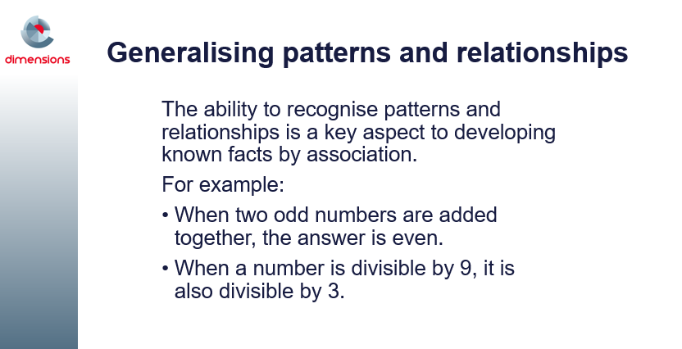
Searching for patterns and relationships helps students to make connections between mathematical ideas and within different contexts. Exploring patterns and relationships leads to generalisation of the properties of the four operations (e.g. using arrays to generalise the commutative property of multiplication).
Lead a discussion in which participants discuss other examples that they have observed in their classrooms, where the recognition of patterns and relationships has resulted in the development of known facts by association by their students.

Slides 6-8: Activity: Properties of operations
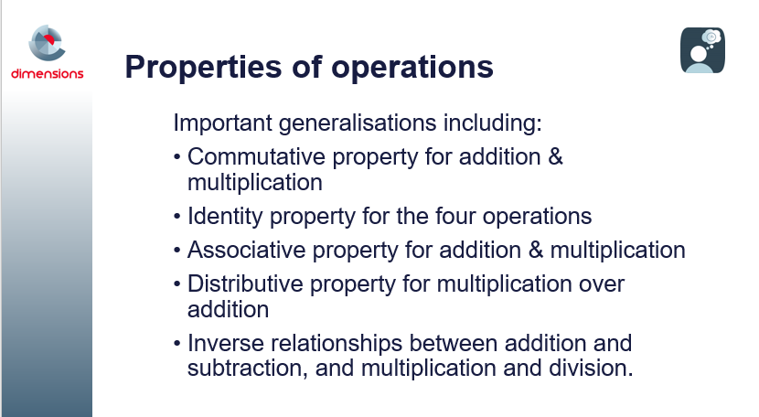

Slide 6 outlines five important generalisations included in the properties of operations.
Commutative Property refers to moving stuff around. E.g.
2 + 3 = 3 + 2; 2×3 = 3×2.
Identity Property refers to a number that when added, subtracted (the identity is 0), multiplied or divided (the identity is 1) with any number does not change the number. E.g. 6 + 0 = 6, 10 – 0 = 10; 29 x 1 = 29; 163/1 = 163
Associative Property refers to grouping. E.g 2 + (3 + 4) = (2 + 3) + 4; 2(3×4) = (2×3)4.
Distributive property of multiplication over addition is used when a number is multiplied by by a sum. E.g. 3(10 + 2) = 3(12) = 36.
Inverse relationship between addition and subtraction. E.g. 3 + 7 = 10; 10 - 3 = 7;
10 - 7 = 3
Inverse relationship between multiplication and division. E.g. 3 x 7 = 21; 21 ÷ 3 = 7;
21 ÷ 7 = 3
Slide 7 shows an example of where understanding the properties of operations leads to transfer of the principles to more complex problems. In Slide 8 participants are asked to think of more examples where students’ understanding of properties of operations results in them be able to use the principles in more complex problems.
e.g. 54 + 48 = (50 + 40) + (4 + 8) = 90 + 12
568 + 876 = (500 + 800) + (60 + 70) + (8 + 6) = 1300 + 130 + 14

Give participants approximately five minutes to discuss their responses in small groups, before sharing with the whole group. It might be useful to record participants’ responses in some way, e.g. butcher’s paper, sticky notes, or electronically.

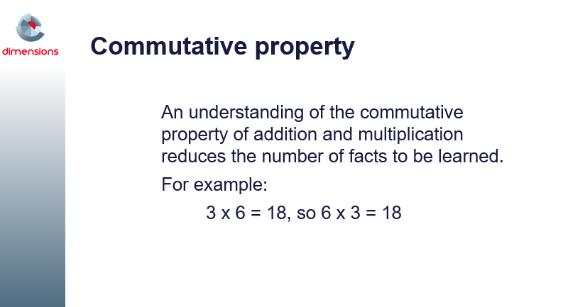
Slides 9 & 10: Commutative property
Also known as the ‘turn around’ property, as the order of adding or multiplying the numbers does not affect the answer.
Lead a discussion in which participants discuss which would be easier for their students to calculate and why?
4 + 7 = ? or 7 + 4 = ?
5 x 7 = ? or 7 x 5 = ?

Slide 11: Video: Masked collections
The image in this slide contains the hyperlink to Vimeo (URL is https://vimeo.com/65120386 ). It is suggested that you download the Vimeo and save it to your hard drive prior to working with this module (and then change the hyperlink to your saved copy of the Vimeo video) to reduce the likelihood of problems associated with possible internet outages.
You can download the “Masked collections” video transcript from http://topdrawer.aamt.edu.au/content/download/21538/285955/file/tdt_MC_maskedcollections_movie_script.pdf

Slide 12: Commutative property for multiplication
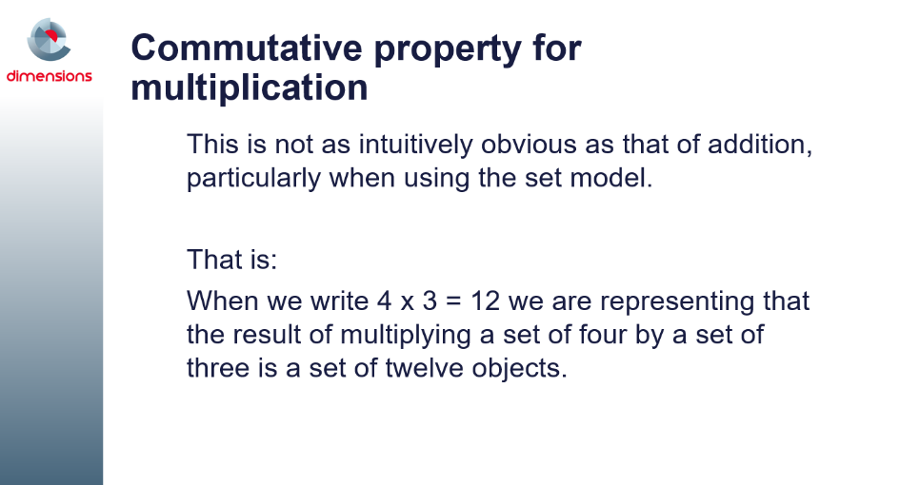
Find out from the participants whether they agree with this statement.
How do they teach the commutative property for multiplication?

Slides 13 – 19: How many marbles?

An animation is used in these slides to demonstrate the commutative property for multiplication. In Slides 14 to 16, the animation is using 7 marbles in each of 99 bags. In Slides 17 – 19 there are 99 marbles in each of 7 bags.
Lead a brief discussion in which participants share whether this is a useful way of teaching the commutative property for multiplication.

Slide 20: Commutative property for multiplication using arrays

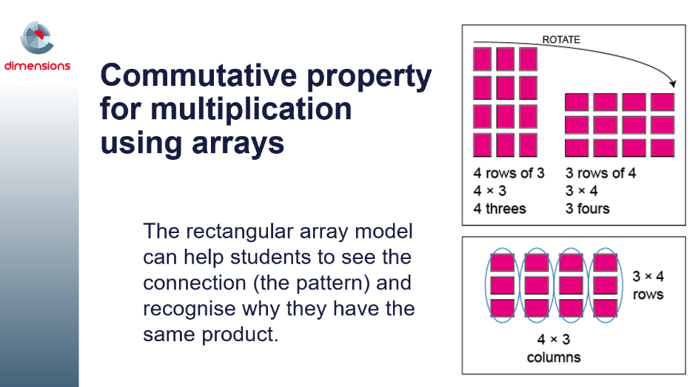
The five slides that follow this one detail a game that the participants can play during the presentation.
Another game which is powerful in supporting and reinforcing student learning and use of the commutative property for multiplication using arrays is Multiplication Toss, in which commutativity is encouraged by exploring the relationship between arrays and regions such as 6 fours and 4 sixes. (accessible from: http://www.education.vic.gov.au/Documents/school/teachers/teachingresources/discipline/maths/assessment/multiplicationtoss.pdf). A similar game, How close to 100, can also be downloaded from YouCubed (accessible from: https://www.youcubed.org/tasks/how-close-to-100/)


Slides 21-25: Activity: What do I know?
Developing an understanding of the properties of multiplication (such as the properties of 0, 1, commutativity) reduce the number of facts students need to remember. In this activity, students build up a list of facts they can recall automatically. They discuss some possible strategies to deal with those that they do not know or need to use additional thinking to work out.
Participants will need:
- Blank multiplication grid (available as a download with this module)
- Two 10-sided dice 0 - 9 (per pair)
- Coloured pencils
The slides provide the instructions to play the game.
The activity is available from http://topdrawer.aamt.edu.au/Mental-computation/Activities/What-do-I-know.
Ask participants to consider the following questions, which could be posed to their students:
- List some of the strategies participants used for the facts that were tricky to work out (e.g. using 4 × 4 and doubles to work out 8 × 4).
- List the facts that were not known. Discuss and list some strategies that might help learn these facts (e.g. 7 × 4 = 5 × 4 + 2 × 4).
- Which facts are known without having to think? Shade these on a blank multiplication grid.
- Which facts can be worked out using doubling or thinking of tens facts? Shade these on the grid.
- Those cells left uncoloured might include some square numbers and some threes, six and seven facts. Discuss the strategies students might use to assist them to remember these facts.

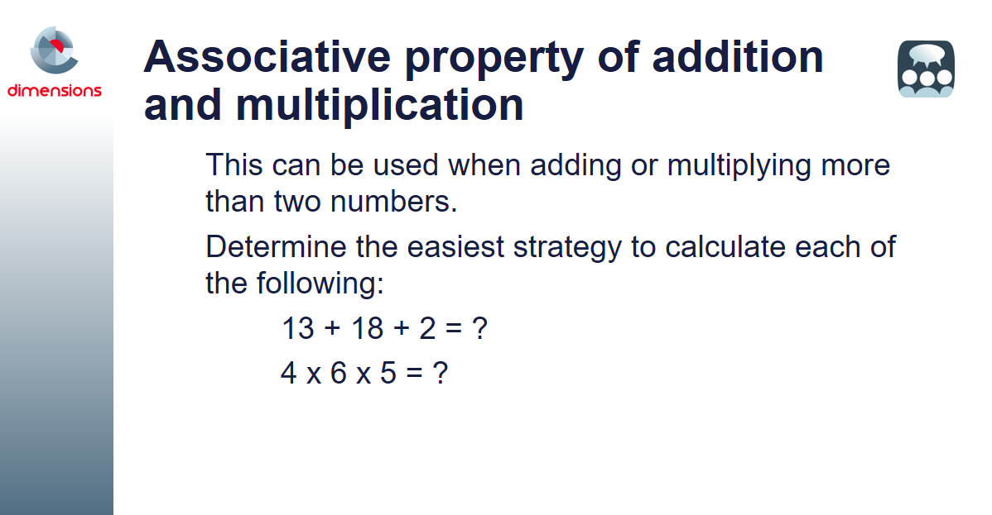
Slide 26: Associative property of addition and multiplication
To work out
13 + 18 + 2 it is easier to add 18 + 2 first than proceed from left to right.
To work out the product of 4 × 6 × 5 it is easier to calculate the 6 × 5 part first then multiply 30 by 4 (or to calculate 4 x 5 first, then
multiply 20 by 6).

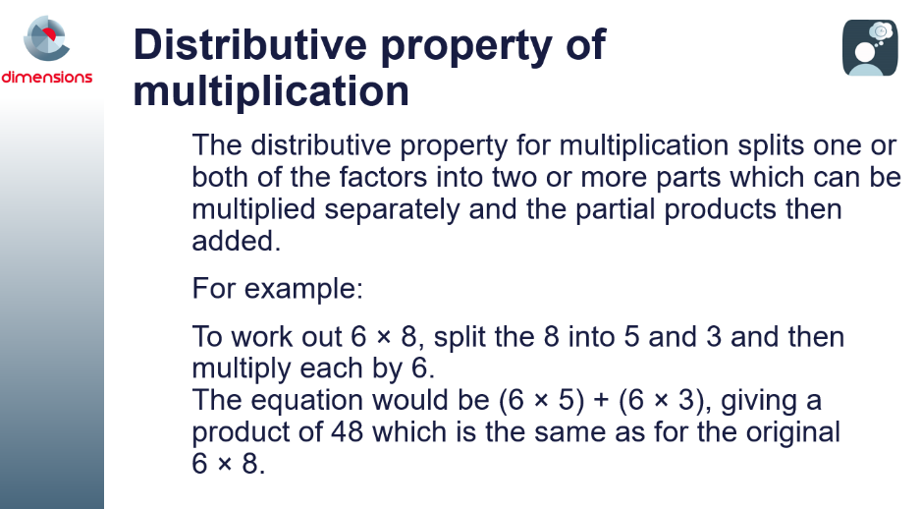
Slide 27: Distributive property of multiplication
The distributive property makes calculations which use larger numbers more accessible by splitting them into several easier mental calculations.
Slides 28 – 45 take participants through the process, using arrays.

Slides 28-45: Distributive property of multiplication
These eighteen slides lead participants through two different ways to split an array to make it easier to mentally calculate a multiplication problem.

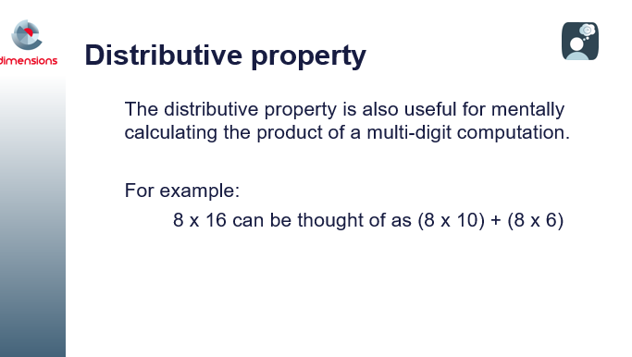
Slide 46: Distributive property
Lead a discussion in which participants discuss using the distributive property to mentally calculate the product of multi-digit computation.

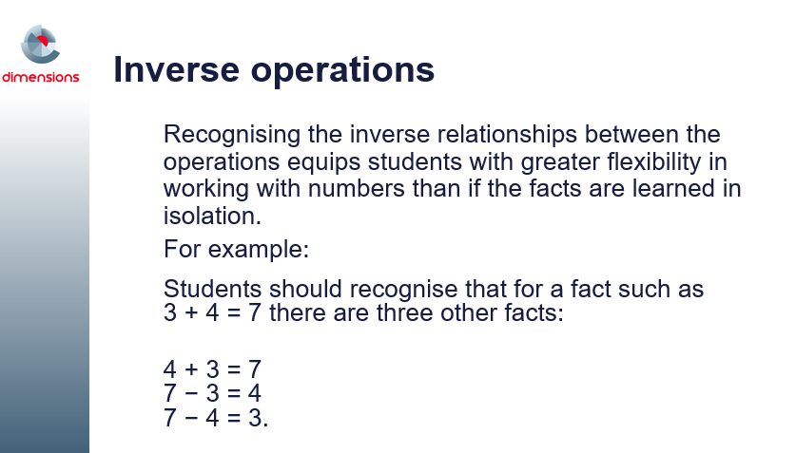
Slides 47-49: Inverse operations
Recognising the inverse relationship between addition and subtraction, and multiplication and division, assists students to generate a family of facts for a given set of numbers.
Knowing this relationship can assist students to think 'addition' when presented with a situation such as 15 – 6 = ? which can be thought of as ? + 6 = 15.
Knowing such relationships can also assist with addition and subtraction of multi-digit numbers.
Tens frames, bead strings and number lines are useful tools to assist students to see these relationships. This will be discussed in greater detail in Module 3 of Mental computation.
The same thinking applies to multiplication and division.
For example, the numbers 4, 5 and 20 have four related facts:
4 × 5 = 20, 5 × 4 = 20, 20 ÷ 5 = 4 and 20 ÷ 4 = 5.
Knowing inverse relationships can assist students:
48 ÷ 6 = ? can be thought of as 6 × ? = 48 or ? × 6 = 48.
Rectangular arrays are a useful tool to assist students to see these relationships.

Slides 50-52: Pattern and structure
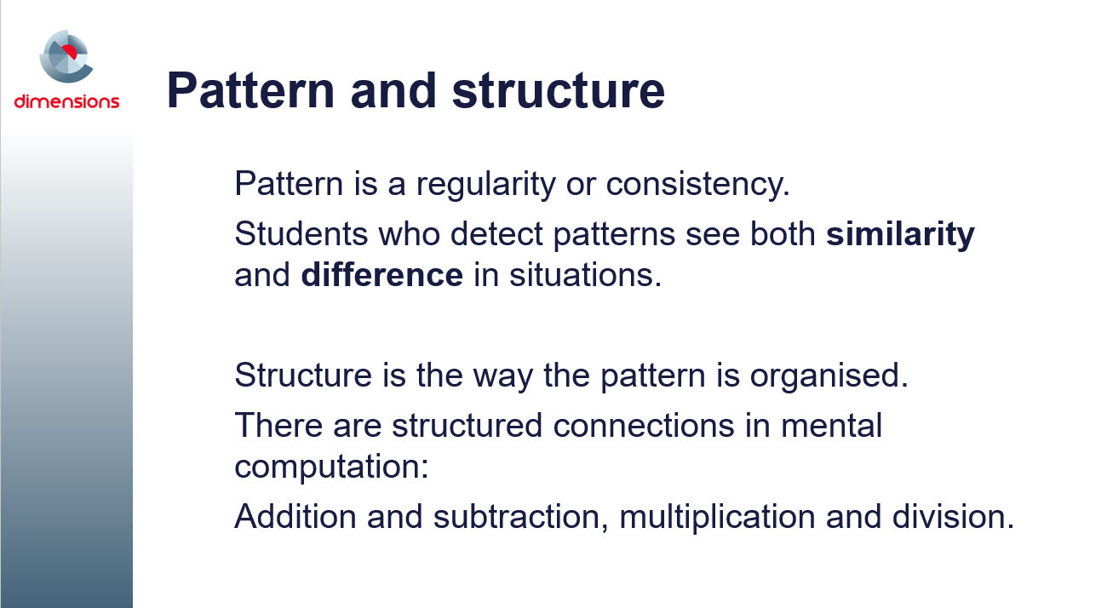
Students with a greater awareness of mathematical pattern and structure tend to do better at mathematics. The good news is that every child’s awareness of mathematical pattern and structure can be improved by appropriate teaching. (ACER; https://www.acer.org/pasa/about).
Many people believe that all of mathematics is about finding, explaining and linking patterns. That is why patterns are included in the Australian Curriculum: Mathematics.
Patterns are especially important in early mathematics learning. They can be fun and creative, and they lead into many fundamental ideas.
- The concepts of multiplication, even and odd numbers, and area measurement all arise from repeating patterns.
- The concepts of division, fractions, time-lines, measurement of length, and numeration all involve equal partitioning — which also relates to repeating patterns.
- Describing how the terms change in a growing pattern can lead to simple algebra.
- Exploration of spatial patterns leads to simple geometry; for example:
  - concepts of symmetry, congruence, collinearity, sides and faces
  - names of common shapes and their basic properties
  - ideas such as tessellations and nets.
Allow participants to read through these three slides before asking them for comments.

Slide 53: Further links to patterns
