

Opening the Top Drawer to mental computation

Module 3: Using manipulatives to support mental computation
  - Information for facilitators
Top Drawer Teachers (http://topdrawer.aamt.edu.au) is a web-based resource developed by the Australian Association of Mathematics Teachers in collaboration with Education Services Australia.
The Mental Computation drawer is one of six drawers which provide expert advice, teaching suggestions and classroom activities. This module is a guide to the use of manipulatives to support mental computation.

About this module
This resource was developed by
Ann Ruckert
It is suitable for
Teachers of students in Years 2 to 6
The resources for this module available on Dimensions include
Facilitator notes
Session slideshow (available as a PowerPoint and a PDF)
Download 1: Pre-reading: Heirdsfield, A. (2002). Mental Methods Moving Along Australian Primary Mathematics Classroom, 7 (1), 4-8
Download 2: 1 to 100 grid: Chart showing numbers from 1–100 arranged in rows of 10. tdt_MC_1to100grid.pdf (one per participant)
Download 3: Multiplication fact grid: Table showing numbers from 0–100 arranged in rows of 10. tdt_MC_multiplicationfactgrid.pdf (one per participant)
Download 4: Blank multiplication fact grid - 10 by 10 grid with numerals 1–10 along the first row and first column. tdt_MC_blankmultiplicationfactgrid.pdf (one per participant)
This module is
The third in a series of three modules on Mental Computation
Designed to take approximately 60 minutes
Learning outcomes (also addressed in Slide 3)
Participants should be able to:
- Describe how manipulatives and representations can be used to support mental computation.
AITSL Standards addressed
Standard 1: Know students and how they learn
1.2 Understand how students learn
Standard 2: Know the content and how to teach it
2.1 Content and teaching strategies of the teaching area
2.5 Literacy and numeracy strategies
Standard 3: Plan for and implement effective teaching and learning
3.3 Use teaching strategies
Standard 6: Engage in professional learning
6.2 Engage in professional learning and improve practice
Australian Curriculum Links
Pages within the Mental computation drawer contain links to the Australian Curriculum which appear to the right of the page in a grey box. These contain links to the content description and elaboration for each item, links to Scootle (resources & community) and to ScOT (Schools Online Thesaurus).

Background
Mental computation is addressed in the Number and Algebra strand of the Australian Curriculum: Mathematics, particularly Number and Place Value, and Patterns and Algebra.
These notes are written to support the delivery of the module. It is recommended that you read them and any supporting materials thoroughly.
You may decide to exclude some activities depending upon the interests and backgrounds of the participants.
Clicking on https://topdrawer.aamt.edu.au/Mental-computation will take you to the overview of the Mental computation drawer of Top Drawer Teachers. It is possible to navigate throughout the drawer from here and it is suggested that the PowerPoint is used as an introduction to these resources, with teachers then able to discover what else is available after the presentation.

Prior to presenting the PowerPoint, distribute the pre-reading, Heirdsfield, A. (2002). Mental Methods Moving Along Australian Primary Mathematics Classroom, 7 (1), 4-8; available as a download with this module. In this article, Ann Heirdsfield explores the issue of how we can encourage students to take ownership of their own mental strategies, especially in relation to students making sense of numbers using their own natural skills.
Ask participants to read the article before attending the professional learning presentation.

Resources
These need to be downloaded/made available for participants.
Pre-reading: Heirdsfield, A. (2002). Mental Methods Moving Along Australian Primary Mathematics Classroom, 7 (1), 4-8 (tdt_MC_heirdsfield1.pdf)
Many Vimeo videos are referred to in the presentation. The image in each slide contains the hyperlink to the Vimeo online. It is suggested that you download each Vimeo and save it to your hard drive prior to working with this module (and then change the hyperlink to your saved copy of the Vimeo video) to reduce the likelihood of problems associated with possible internet outages.
1 to 100 grid: Chart showing numbers from 1–100 arranged in rows of 10. tdt_MC_1to100grid.pdf (one per participant)
Multiplication fact grid: Table showing numbers from 0–100 arranged in rows of 10. tdt_MC_multiplicationfactgrid.pdf (one per participant)
Blank multiplication fact grid - 10 by 10 grid with numerals 1–10 along the first row and first column. tdt_MC_blankmultiplicationfactgrid.pdf (one per participant)
Bead strings (one per participant, if available)
Sets of 24 tiles (one set per participant)
One ten-sided die per participant
A4 paper (some for each participant), pen/pencil
Access to the internet

Slide 2: The modules in this PL
The content in the Mental Computation Top Drawer will be addressed in three modules. In this module we will be examining what mental computation is and why it is important. The remaining two modules are:
Module 1 of 3: What is mental computation? Why is it important?
Module 2 of 3: Noticing patterns and relationships

Slide 4: What are manipulatives?
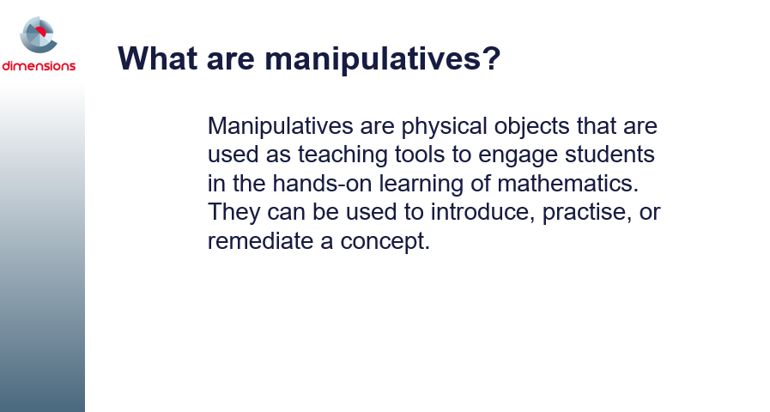This definition has been accessed from https://www.teachervision.com/using-manipulatives.
A useful pdf document for participants to access is; Research on the Benefits of Manipulatives available from: https://www.hand2mind.com/pdf/learning_place/research_math_manips.pdf

Ask participants to briefly give examples of the types of manipulatives used in their classrooms.

Slide 5: Mental load
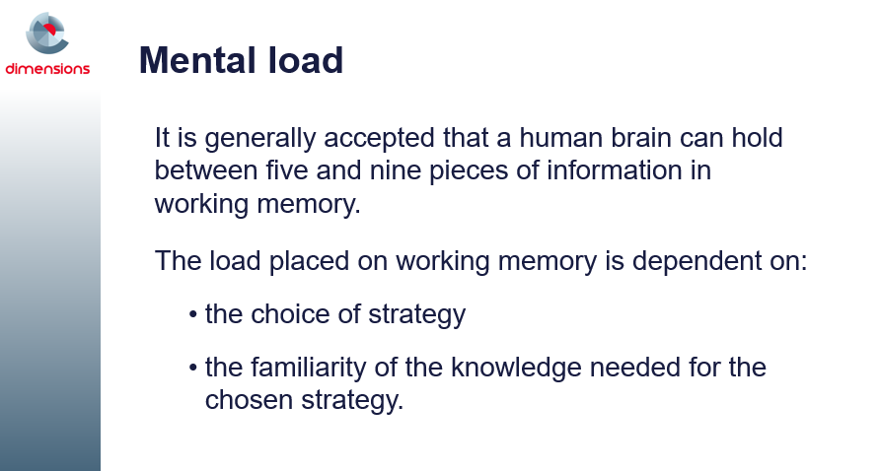
Movement, including the use of manipulatives, gestures and body movement, can allow learners (of all ages) to reduce their brain’s processing power or mental load, leaving more resources for other activities or cognitive processes, which can result in improvements of problem-solving abilities (Sweller, 1988). For example, instead of trying to imagine how an object would appear when rotated, learners can reduce this burden of tracking information by allowing their hands to do it and seeing what happens. Freeing up those mental resources can allow them to think more deeply about spatial relations and have a better understanding of that concept before transitioning to spatial reasoning more abstractly. In a similar vein, gestures during explanations of math problems also help learners to track their thinking and reduce working memory usage so that they can allocate more cognitive effort to problem solving (Goldin-Meadow, Nusbaum, Kelly, & Wagner, 2001).
Accessed from Tran, C., Smith, B., & Buschkuehl, M. (2017). Support of mathematical thinking through embodied cognition: Nondigital and digital approaches. Cognitive Research, 2(1), 16. http://doi.org/10.1186/s41235-017-0053-8 (retrieved from https://www.ncbi.nlm.nih.gov/pmc/articles/PMC5321706/pdf/41235_2017_Article_53.pdf)
Lead a brief discussion in which participants share experiences where they have struggled to learn something new because their brains felt ‘too busy’. An example could be when they started to learn to drive a car.

Slides 6-7: Should mental computation involve the use of manipulatives?
These slides links with the previous slide and the discussion begun for the previous slide could continue here, if appropriate.
According to Stein and Bovalino (Stein, M. K. & Bovalino, J. W. (2001). Manipulatives: One piece of the puzzle. Mathematics Teaching in Middle School, 6(6): 356–360.), “Manipulatives can be important tools in helping students to think and reason in more meaningful ways. By giving students concrete ways to compare and operate on quantities, such manipulatives as pattern blocks, tiles, and cubes can contribute to the development of well-grounded, interconnected understandings of mathematical ideas.”
Students who calculate mentally are able to visualise problems and work them out in their heads.
To do so, however, they require practical experiences and models that can help them apply these problems to the real world.
Students should be provided with appropriate resources that they can use to observe the problem, apply the strategy, and visualise the solution.
Such resources include coins, counting sticks, number cubes, base-10 blocks, interlocking cubes, counters, number lines, 100-squares, bead strings, place-value cards, diagrams of shapes divided into fractional parts, paper-folding, etc.
Interactive whiteboards are also useful, as they allow students to manipulate images and thereby visualise a solution.
Accessed from http://www.sunrisesd.ca/ServicesPrograms/NTK12/Documents/September%202016.pdf

Slide 8: Mental computation development cycle
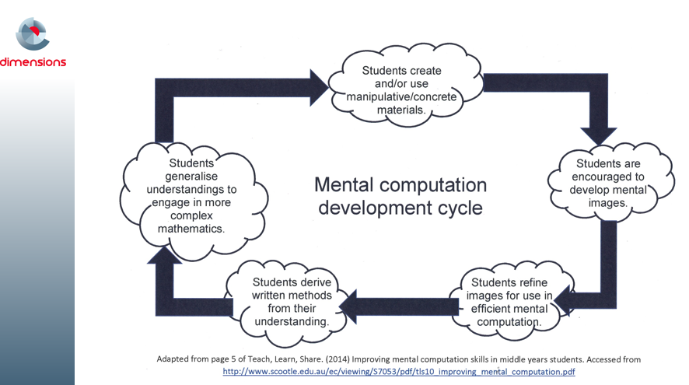
This cycle is adapted from page 5 of Teach, Learn, Share. (2014) Improving mental computation skills in middle years students. Accessed from http://www.scootle.edu.au/ec/viewing/S7053/pdf/tls10_improving_mental_computation.pdf) and details how students progress from using manipulatives (and representations), to developing mental images (supporting mental computation), written methods, and through to generailsation.

Slide 9: Should mental computation involve the use of manipulatives?
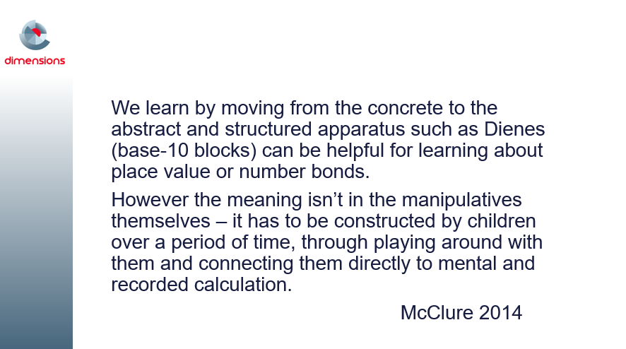
The quote is taken from McClure, L. (2014). Developing Number Fluency – What, Why and How? Accessed from https://nrich.maths.org/10624. It concludes with the question of whether mental computation should involve the use of manipulatives, while making the point that it is not the manipulatives themselves that are making the meaning of the computation clear, but the way in which students engage with them.
The remaining slides in this module examine several manipulatives and representations, and how they can be used to support student learning and mental computation. The final slides in the module provide links to further resources that participants can use with their students.

Slides 10 – 13: Bead strings
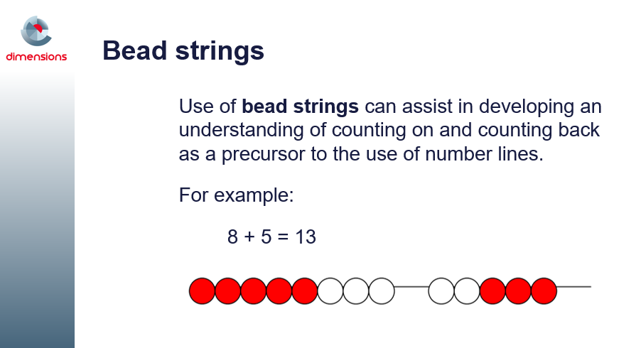
These four slides describe how bead strings can be used to support students’ mental computation.
If you have access to bead strings, ask participants to use them to add two 2-digit numbers together, using the methods described on slides 11 and 12. Note that the process is recorded on the paper on which the beads rest. Do the participants feel that this is necessary, or will the use of pegs achieve the same result?

Slide 13 contains a video (URL is https://vimeo.com/64689008) demonstrating the use of a bead string when working with ‘up-through-ten’.
You can download the “Up-Through-Ten” video transcript from http://topdrawer.aamt.edu.au/content/download/21461/285298/file/tdt_MC_upthroughtens_movie_script.pdf.

Slides 14 – 26: Ten frames, cube stacks and finger patterns

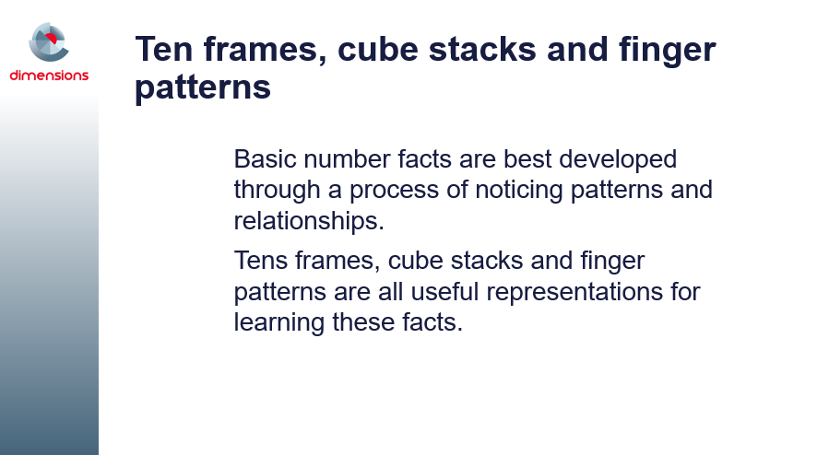
This set of slides provides examples of how to use ten frames, cube stacks and finger patterns to support students’ mental computation processes.
Slide 15 contains a video (URL is https://vimeo.com/64691633) that demonstrates how to use ten frames to support the concept of working in groups of ten, thus making computation easier.
You can download the “Adding Tens” video transcript from http://topdrawer.aamt.edu.au/content/download/21445/285138/file/tdt_MC_addingtens_movie_script.pdf
Slides 16 – 20 demonstrate how to use cube stacks to learn doubles.
Slide 21 contains a video (URL is https://vimeo.com/64858419) that demonstrates using ten frames while linking the learning with using fingers and cube stacks. Linking between different representations will help to solidify students’ learning, understanding and ability to work with mental computation.
You can download the “ Using Tens Frames with Fingers” video transcript from http://topdrawer.aamt.edu.au/content/download/21458/285268/file/tdt_MC_tensfingers_movie_script.pdf.

Slides 22 – 26 demonstrate how to use cube stacks to bridge ten.
Lead a discussion in which participants share:
- whether/how they have used these three different representations/manipulatives in their classrooms.
- Have they found them useful to support student learning?
- Have they tended to use one in preference to the others? If so, why?

Slide 27: Manipulatives and representations to support multiplication and division facts
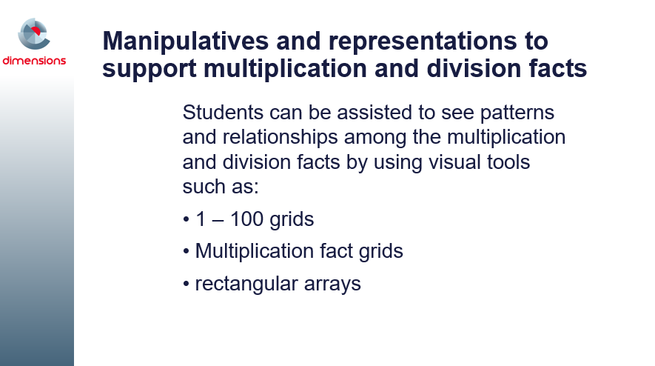
1–100 chart and multiplication fact grid are both available as handouts, and are available with this module in dimensions.
When students investigate patterns on a 1–100 chart or on a multiplication fact grid, it assists their understanding of properties (e.g. the identity and commutative properties).
Display the multiplication fact grid and give the participants a few minutes to discuss in pairs any patterns they notice.
Ideas for using these visual tools in the classroom follow:
- In class you could list students' ideas on the board (e.g. the first row and column in the unshaded section are all zeros, the second row and column are counting by ones, each column has a corresponding row that is the same).
- Use a 1–100 number grid in a 10 by 10 shape to explore sequences of multiples by shading each multiple in a different colour.
- This can lead to generalisations, such as every second multiple of 2 in the twos' sequence (2, 4, 6, 8, 10, 12…) is also a multiple of 4.
- Students could see if the same relationship exists for any other multiples (e.g. threes and sixes; fives and tens).
- Identifying the patterns that exist within the multiplication facts can assist students to identify and generalise divisibility patterns. For example, a number is divisible by five if it ends in a five or zero.
- An activity that participants may like to use with their students to reveal the patterns found in 1 – 100 grids is the Sieve of Eratosthenes. Available from a number of places, one source is: http://www.doe.virginia.gov/testing/solsearch/sol/math/5/mess_5-3a.pdf.
Good teaching of mental calculation of multiplication and division uses physical models and a variety of learning experiences including games, everyday contexts and opportunities for students to build connections.
Visualising arrays
Rectangular arrays help students see the multiplicative structure. Rectangular arrays also show the commutative nature of multiplication.
An array is a rectangular arrangement of objects in equal rows (horizontal) and equal columns (vertical).
Everyday examples of arrays include a muffin tray and an egg carton.
Partial arrays
Array structures are ways to represent factors. In this activity, students are given the number of tiles in each row and column and are asked to find the total number of tiles needed to construct the rectangle.
Factors are pairs of counting numbers that multiply to give another counting number. They can be represented by arrays.
Make a partial array on the board (e.g. 6 by 5). Ask the students to predict the number of tiles they think were used to make the complete array and how they might work it out.
Students play a game of 'How many tiles do I need to pave the floor?'
For example, ask students to generate as many arrays for 12 as they can, either using concrete materials or shading in grid paper. Record each of the facts. In pairs, students can discuss any connections or patterns they notice in what they have recorded.
Visual representation of the arrays can assist students to see connections such as commutativity, and doubling and halving of the factors. This can lead to generalisation.

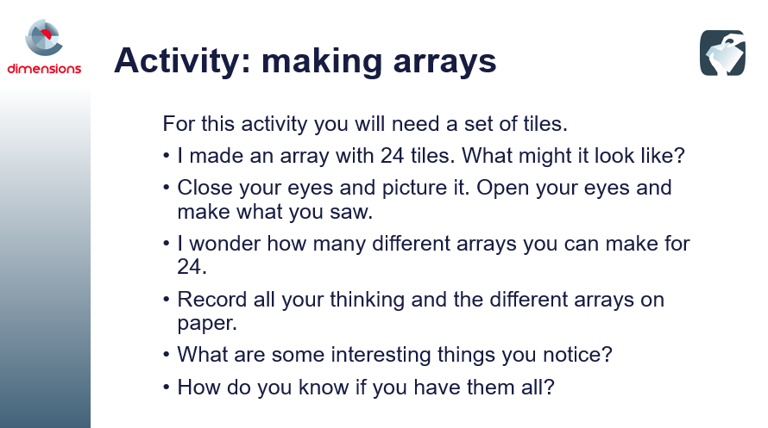

Slide 28: Activity: making arrays
This activity has been written as though it were to be presented to a class of students. Ask participants to work through it, then lead a discussion in which they can share their responses to the activity.
How might they use this with their students?
Do they recognise that by rotating the structure they generate another arrangement?
Participants can share the different possibilities and draw them on the board or interactive whiteboard. Here are some questions that their students could be asked:
- What is the same about all the arrays?
- What is different?
- What do you notice about the number of rows and number of tiles in each row?
Pose extension problems such as:
- I wonder if another number such as 36 would have as many different possible arrays as 24?
One of the activities in the Sieve of Eratosthenes pdf (http://www.doe.virginia.gov/testing/solsearch/sol/math/5/mess_5-3a.pdf) relates to this slide as well.

Slide 29: Activity: splitting arrays
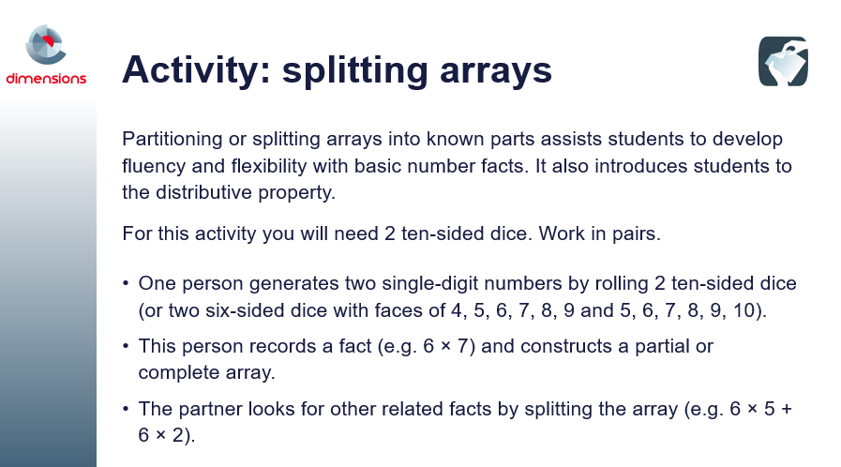
In the classroom students can work together to find another way to split the array using known facts. Opportunities arise for noticing square numbers, and doubling and halving connections. This is a useful way to develop flexibility and strategic choice.
Ask participants to work through the activity.
A blank 10 by 10 grid can be downloaded and used to record the splits. Using different colours makes the connections clear.
Encourage participants to generate a list of multiplication facts that students find difficult, and consider how they might partition them to make the mental calculation easier.
Make a group chart of the different strategies.
This activity can be extended in class so students mentally calculate the product of a two-digit and a one-digit number using partitioning strategies to make the calculation easier.
Once participants have worked through the activity, lead a discussion in which they can share their responses to the activity. How might they use this with their students?
Another game which is powerful in supporting and reinforcing student learning and use of the commutative property for multiplication using arrays is Multiplication Toss, in which commutativity is encouraged by exploring the relationship between arrays and regions such as 6 fours and 4 sixes. This game also encourages students to split arrays in order to ‘fit’ their thinking in the grid. Participants might like to look at this resource, if there is time (accessible from: http://www.education.vic.gov.au/Documents/school/teachers/teachingresources/discipline/maths/assessment/multiplicationtoss.pdf).

Slide 30: Developing number sense using manipulatives
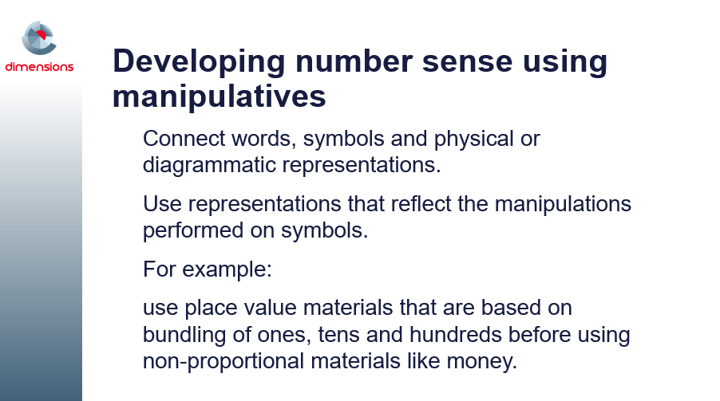
With long-term use of manipulatives in mathematics, educators have found that students make gains in the following general areas:
- verbalizing mathematical thinking
- discussing mathematical ideas and concepts
- relating real-world situations to mathematical symbolism
- working collaboratively
- thinking divergently to find a variety of ways to solve problems
- expressing problems and solutions using a variety of mathematical symbols
- making presentations
- taking ownership of their learning experiences
- gaining confidence in their abilities to find solutions to mathematical problems using methods that they come up with themselves without relying on directions from the teacher
(Heddens; Picciotto, [Picciotto, H. (1998). Operation sense, tool-based pedagogy, curricular breadth: a proposal, accessed at http://www.picciotto.org]; Sebesta and Martin, [Sebesta, L. M. & Martin, S. R. M. (2004). Fractions: building a foundation with concrete manipulatives. Illinois Schools Journal, 83(2): 3–23.])

Slide 31: Place value understanding
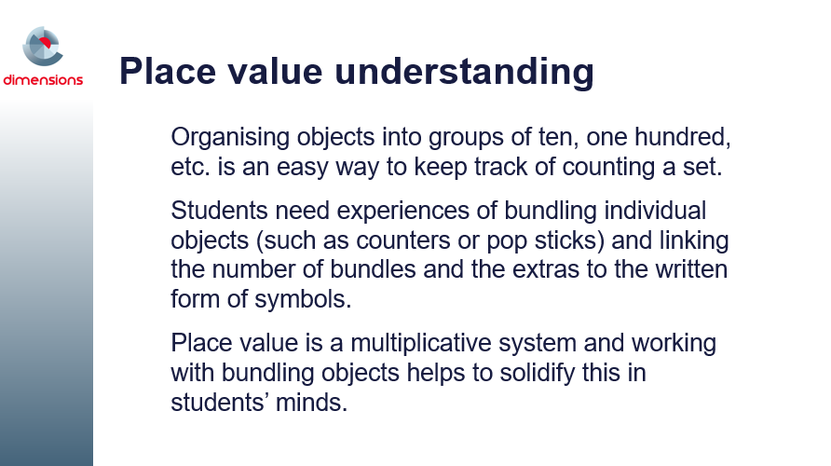
It is important to understand that the structure of the place value system is based on grouping in tens. The additive and multiplicative nature of the system is useful in developing a sense of flexibility with numbers.
Use of an empty number line can make students' thinking visible and represent different strategies used.
Understanding the place value system is necessary when:
- multiplying by powers of 10
- multiplying multi-digit numbers by a single digit using the distributive property.
Students' understanding of place value reflects their understanding of counting, as well as their thinking about the operations of addition, subtraction, multiplication and division.

Slide 32: Bundling pop sticks
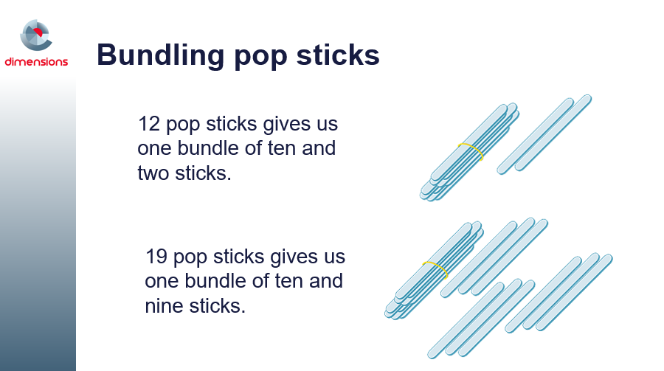
Progress in mental calculation involves a transition from counting, to additive thinking, to multiplicative thinking. Bundling objects into groups of ten assist students to move along the continuum.
There are key indicators of increased efficiency in mental calculation strategies.
- Counting based strategies start with treating sets as collections of ones.
Students solve problems by counting every object.
This includes joining sets (addition and multiplication) and separating a set (subtraction). Sharing is done one object at a time.
- Additive strategies involve treating sets as collections that can be partitioned and combined.
The first evidence of this is counting on and back to solve addition problems, and skip counting to solve multiplication problems.
When students learn that collections can be partitioned and recombined they use their knowledge of number facts to work out new results and solve more difficult problems.
- Multiplicative thinking involves using the properties of multiplication and division.
Students distinguish which of the four operations to apply to situations.

Slide 33: Video: Differences
This video (URL is https://vimeo.com/64700076) demonstrates another strategy to bundle individual objects. In the video, film canisters are being used as tens and beans as ones. The video shows and explains the calculations made from beans put in the canisters and the loose ones.
You can download the “Differences” video transcript from http://topdrawer.aamt.edu.au/content/download/21449/285178/file/tdt_MC_differences_movie_script.pdf

Slides 34 & 35: Conclusion
The preceding slides shared information, videos and slide presentations from Top Drawer Teachers Mental computation resources.
There are many more examples to be found at http://topdrawer.aamt.edu.au/Mental-computation as well as the manipulatives and representations found in schools and designed by teachers and their students.
Use them wisely to support student learning and understanding, and mental computation. Keep in mind that older students benefit as well from using manipulatives and representations when learning new concepts in mathematics.
Student activities that appear in other parts of the drawer have been collected in the ‘Activities’ section of Mental Computation, found at:
http://topdrawer.aamt.edu.au/Mental-computation/Activities
If you have time now, take a look at an activity from this website.

Slide 36: Further links to other mathematical concepts
The following document offers excellent support to the teaching of mental computation:
http://www.education.vic.gov.au/Documents/school/teachers/teachingresources/discipline/maths/assessment/lafcomparativ.pdf
The information in this document describes the eight zones within the Learning and Assessment Framework for Multiplicative Thinking (LAF), developed by Professor Dianne Siemon through the Scaffolding Numeracy in the Middle Years (SNMY) project.
Further information about this project is available at: http://www.education.vic.gov.au/school/teachers/teachingresources/discipline/maths/assessment/Pages/scaffoldnum.aspx.

