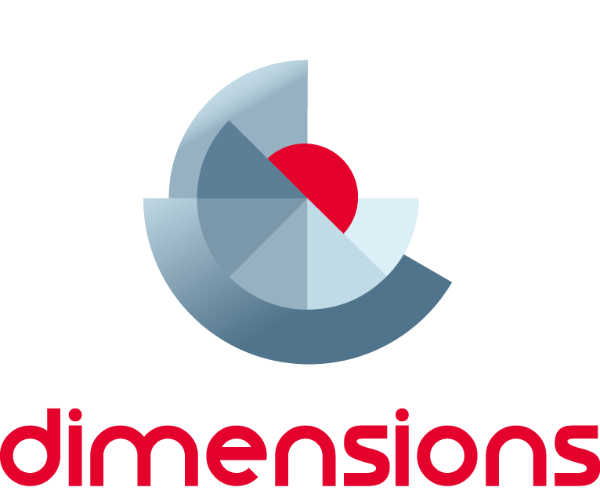

TDT Reasoning:

Module 3 – Deduction and Proof
  - Information for teachers
Top Drawer Teachers (http://topdrawer.aamt.edu.au) is a web-based resource developed by the Australian Association of Mathematics Teachers in collaboration with Education Services Australia.
The Reasoning drawer is one of four drawers which provide expert advice, teaching suggestions and classroom activities. This module is a guide to two of the ‘big ideas’ of Reasoning.

About this module
This resource was developed by
Libbie Spohn
It is suitable for
Years 6 to Years 10
The resources for this module include
Facilitator notes
Session slideshow (available as a PowerPoint and a PDF)
This module is:
The third (final) in a series of three modules on Reasoning
Designed to take between 45 and 60 minutes
Learning outcomes
- To explore the “Big Ideas of Reasoning” – Deduction and Proof
- Understand deduction and proof in the context of reasoning and there connection to the Australian Curriculum.
- To explore activities to assist in the teaching of deduction and proof
AITSL Standards addressed
Standard 1: Know students and how they learn
1.2 Understand how students learn
Standard 2: Know the content and how to teach it
2.1 Content and teaching strategies of the teaching area
2.5 Literacy and numeracy strategies
Standard 3: Plan for and implement effective teaching and learning
3.4 Select and use resources
Standard 6: Engage in professional learning
6.1 Identify and plan professional learning needs
6.2 Engage in professional learning and improve practice

Background

In Mathematics, the key ideas are the proficiency strands of understanding, fluency, problem-solving and reasoning. The proficiency strands describe the actions in which students can engage when learning and using the content. While not all proficiency strands apply to every content description, they indicate the breadth of mathematical actions that teachers can emphasise.

Reasoning is one of the four proficiencies in the national curriculum, which describes it as a capacity for logical thought and actions. Reasoning develops throughout the curriculum and there are identifiable milestones.

As stated from the ACARA website:

“Students develop an increasingly sophisticated capacity for logical thought and actions, such as analysing, proving, evaluating, explaining, inferring, justifying and generalising. Students are reasoning mathematically when they explain their thinking, when they deduce and justify strategies used and conclusions reached, when they adapt the known to the unknown, when they transfer learning from one context to another, when they prove that something is true or false, and when they compare and contrast related ideas and explain their choices.”

These notes are written to support the delivery of the module. It is recommended that you read them and any supporting materials thoroughly.

You may decide to exclude some activities depending upon the interests and backgrounds of the participants.

Clicking on http://topdrawer.aamt.edu.au/Reasoning/Big-ideas will take you to the Big Ideas in Reasoning page of Top Drawer Teachers. It is possible to navigate throughout the drawer from here and it is suggested that the PowerPoint is used as an introduction to the Reasoning resources, with teachers then able to discover what else is available after the presentation.

Resources

Handouts/worksheets: http://topdrawer.aamt.edu.au/Reasoning/Downloads/Max-s-statements

Magic V’s worksheet: https://nrich.maths.org/content/id/6814/NRICH-poster_MagicV.pdf

Videos: For slide 14 https://vimeo.com/63131976
For slide 17 Part 1: https://youtu.be/-JrZcMbsNdA
Part 2: https://youtu.be/3fx7A8WRfk8

Slide 5 & 6: Australian Curriculum Links

On this slide the links to the Australian Curriculum: Mathematics content descriptions related to the big ideas of ‘deduction’ and ‘proof’ are provided. These links contain the content description and elaboration for each item, links to Scootle (resources & community) and to ScOT (Schools Online Thesaurus); which will assist in relating this session to topics being taught in the classroom. It would be a good idea to follow at least one of the links to show what is available on the Australian Curriculum website.

Slide 7: Big Ideas
There are six Big Ideas in the Reasoning Top Drawer. In this module we will take a look at Deduction in Year 1 to 10 and Proof in Year 10.

Slide 8: Focus Question
Have participants discuss the focus question in pairs/ small groups.
Some ideas to emphasise with the participants:
- Deductive reasoning is a valid form of proof. It is, in fact, the way in which geometric proofs are written. Deductive reasoning is the process by which a student makes conclusions based on previously known facts.
- Deduction involves drawing a conclusion from a broadly accepted proposition through one or more logical steps.
- Deductive reasoning is an important skill to be developed in mathematics classrooms at all levels. General principles can be applied to specific circumstances to arrive at a true conclusion.
Slide 9: Example of Deductive reasoning
General principles can be applied to specific circumstances to arrive at a true conclusion.
Show participants the example on this slide.
In deductive reasoning, general principles are applied to specific instances. If the original premises are true, conclusions based on deductive reasoning are also true.
Discuss small group solutions

Slide 10: Activity

This activity can be downloaded from: http://topdrawer.aamt.edu.au/Reasoning/Downloads/Max-s-statements
Max's Statements is an activity involving deduction to try with students from years 5–9.
Have participants work in small groups to try to work out if both of Max’s statements were true for all cases or disprove the statements.
Hand out a copy of “Max’s statements to each participant.
Another activity would be to show that there are 180 degrees in a triangle by drawing a triangle on a piece of paper and then tearing the vertices off and putting them together at a point to show the angles make a straight line.

Slide 11: Proof

Now consider the final idea, proof in Year 10, of the six big ideas.

Slide 12: Australian Curriculum Links

On this slide the links to the Australian Curriculum: Mathematics content descriptions related to the big ideas of ‘deduction’ and ‘proof’ are provided. These links contain the content description and elaboration for each item, links to Scootle (resources & community) and to ScOT (Schools Online Thesaurus); which will assist in relating this session to topics being taught in the classroom. It would be a good idea to follow at least one of the links to show what is available on the Australian Curriculum website.

Slide 13: Proof
Mathematics depends on proof for its development, usefulness and veracity.
Proof is the foundation of mathematics, so proving is a foundation skill in school mathematics.
Sometimes, only one example is needed to prove something: a visitor to Australia from England only needs to see one black swan as proof that swans can be black as well as white. Students sometimes transfer this logic to mathematics, arguing that because something holds true for one example (or a number of examples), then it has been 'proved' to be true.
In mathematical proof, a mathematical axiom, which is a basic proposition, is assumed to be true. The axiom is used to show that a consequent mathematical statement will always be true. Proof is deductive in nature and 'if–then' statements are used in deductive reasoning.

An unproven proposition that is believed to be true is known as a conjecture. Proof adds the authority of clear, deductive, sequential argument that applies to all cases.

Slide 14: Proof: the foundation of mathematics
Deductive reasoning applies general principles to specific instances.
Primary students are capable of arguing deductively.
Show participants the video
https://vimeo.com/63131976

Slide 15: Activity
Distribute the Magic V handout
Magic V sheet can be found following the link below:
http://topdrawer.aamt.edu.au/Reasoning/Big-ideas/Proof/Proof-The-foundation-of-mathematics or http://nrich.maths.org/6274/note

Slide 16: Activity
Have participants work independently of others
Then share ideas with group members

Slide 17: Video
Show participants the video Part 1 and then Part 2 of teachers working on the Magic V activity.
It may not be necessary to show all of the videos if participants have developed a strong understanding of the activity.
Now would be a good time to ask how you would develop a formal proof to show that you have all of the ways of doing the activity. What conditions do the five numbers have to follow for the Magic V to work? What is the difference between the first of the five numbers being an odd number and the first of the five numbers being an even number?

Slide 18: Pythagoras Theorem
There are many ways to solve Pythagoras Theorem and this could be a great activity to get into more formal proofs. A search of the Internet for ‘Pythagoras Theorem proofs’ will provide numerous links or Wikipedia has a number of proofs. https://en.wikipedia.org/wiki/Pythagorean_theorem#Other_proofs_of_the_theorem

Slide 19: Acknowledgements
Acknowledgements for the Top Drawer Reasoning

Summary

Ask participants where they could apply the big ideas of Deduction and Proof in their classrooms with their students.

Have participants share some ideas.

Further ideas
Further reading on Proof: http://nrich.maths.org/2838

Further reading on Reasoning: http://www.aamt.edu.au/Library/TDT-Readings/Reasoning/tdt_R_stacey1.pdf
Magic V task on Nrich: http://nrich.maths.org/6274

